
Mighty Writing

For the last two weeks, we have been looking at the traditional tale of Hansel and Gretel. For Mighty Writing on Monday 1st February we would like the children to retell the beginning of the story in their own words.
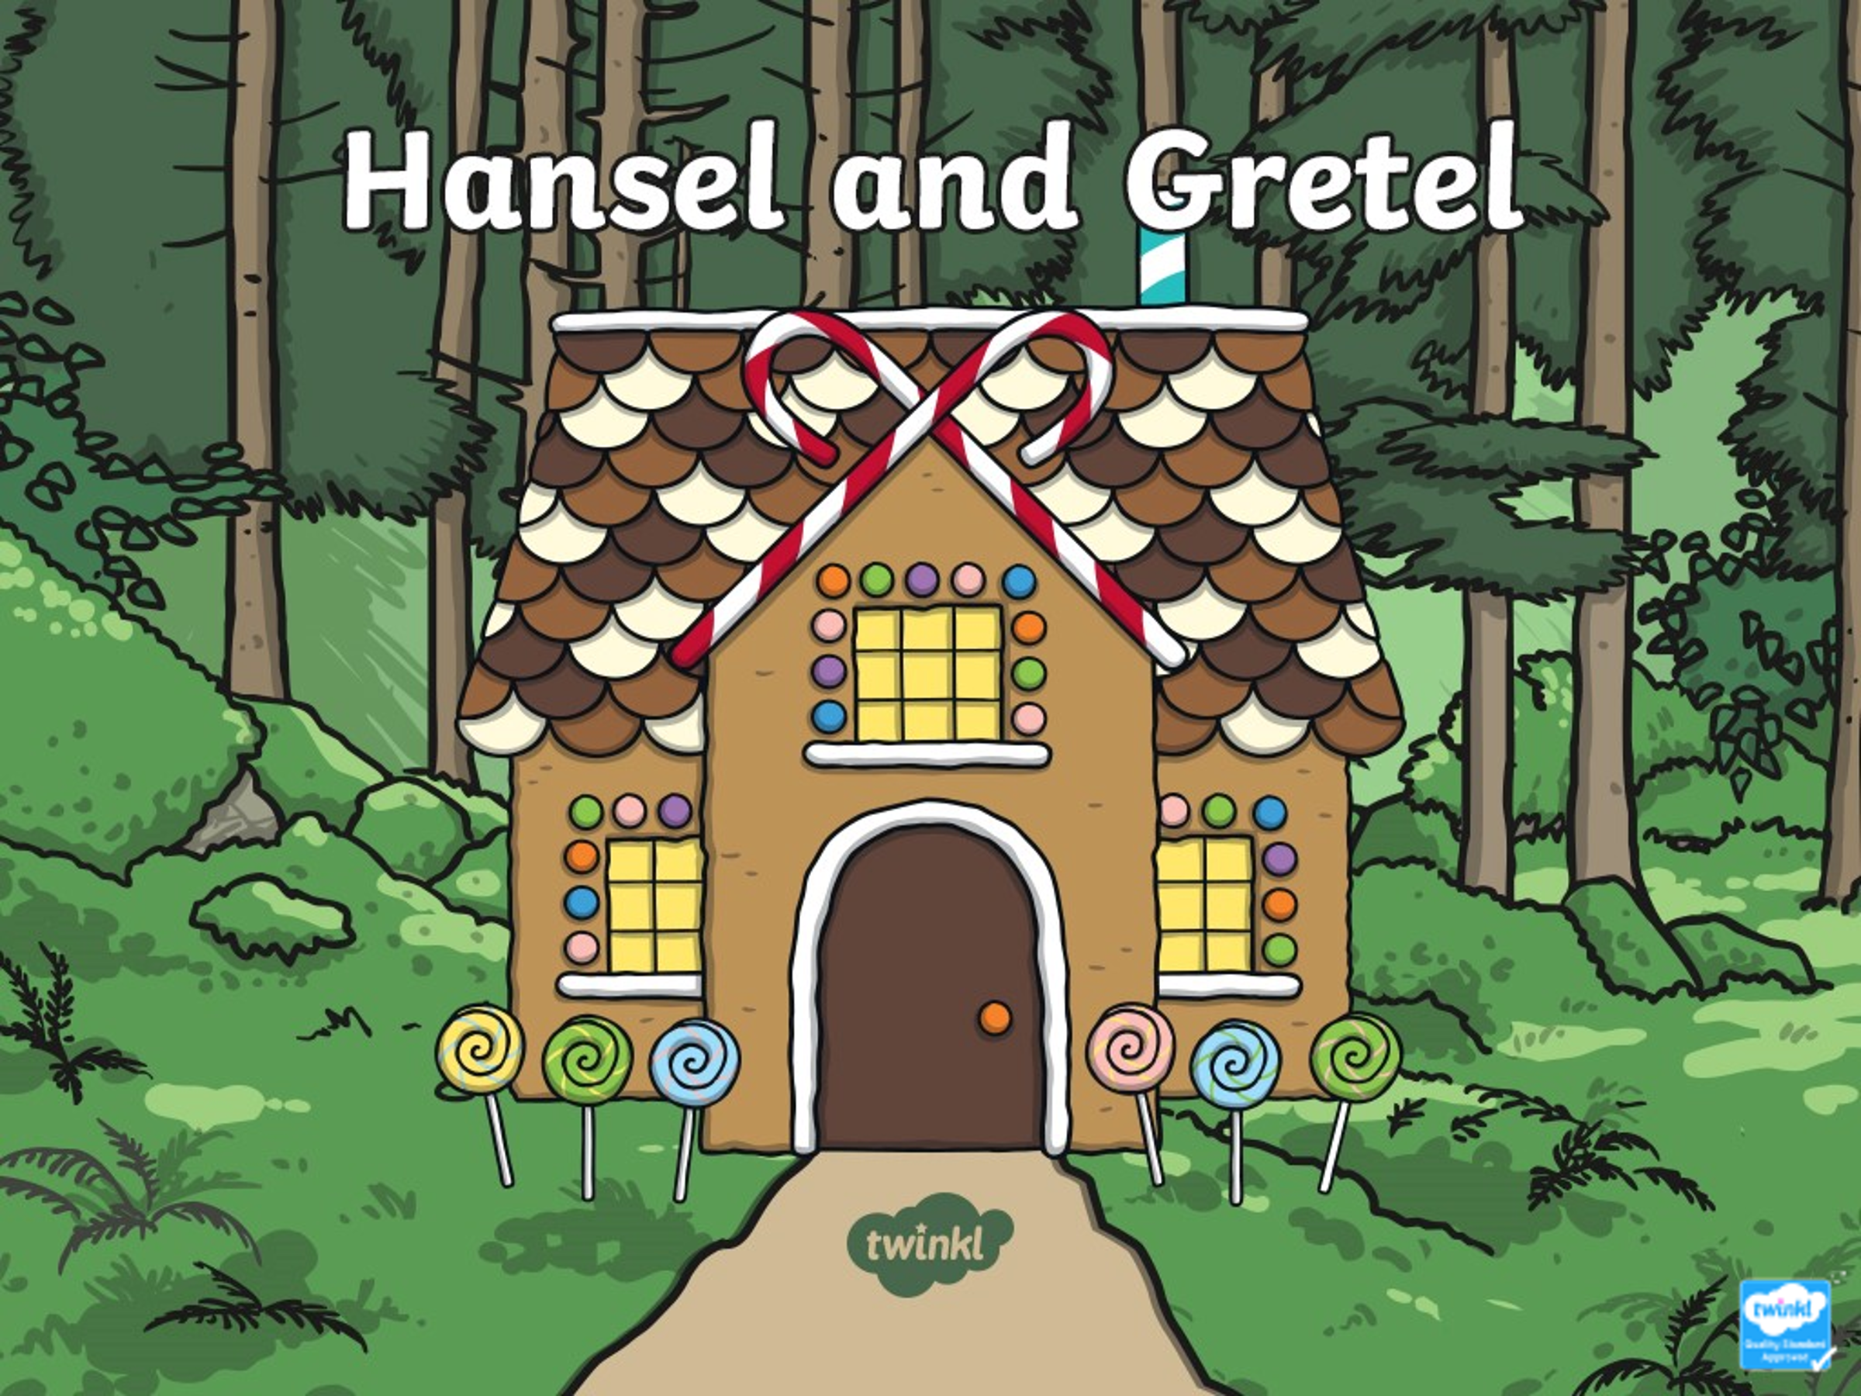

Click on the Power Point on the website and use this to remind you of the story. Then, practice retelling the story verbally. You could use the picture cues (also on the website) to help you.
When you do your writing on Monday, you can use these picture cues to help you.
How does the story start?
Where does the story start?
Who are the characters?
What happens at the beginning of the story?

