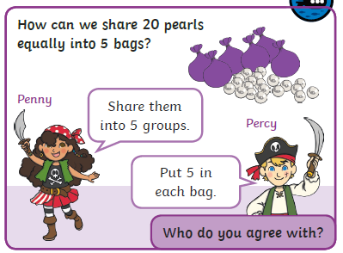

Don’t forget to use objects from around your house to help you to decide who you agree with.

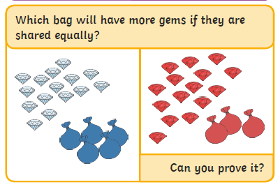

You might like to use objects from around your house to help you to solve this.
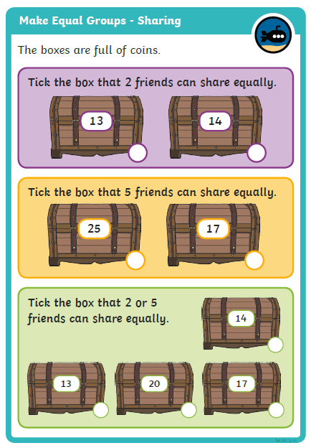
Which box could be shared by either two or five children?
Can you spot any number pattern clues?
Can you prove it with objects?
How many would they get each?
Can you use a stem sentence to explain this like you did before?
Think about the same things as you did above.

Which number can be shared equally between two friends?
Are there any number pattern clues that can help us?
Can you prove it with objects?
How many would they get each?
Can you use a stem sentence to explain this like this:
___ can be shared by ___ friends. They each get ___.
Repeat for the ‘five friends’ challenge.

