28.1.21 I can solve problems involving division as sharing.

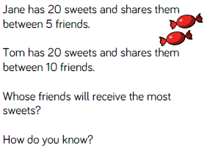

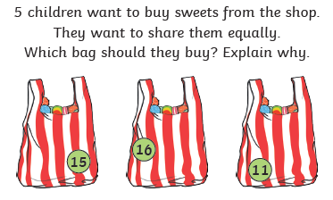
- Which of these numbers would be shared equally between five children?
- How do you know?
- Can you prove it with a picture?
- Can you write the number sentence that represents this?

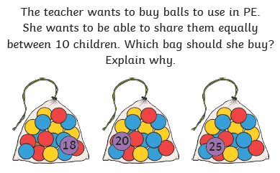
- Which of these numbers could be shared equally between ten children?
- Why do you think that?
- I think 18 could be shared equally between ten children. Can you prove I am wrong?

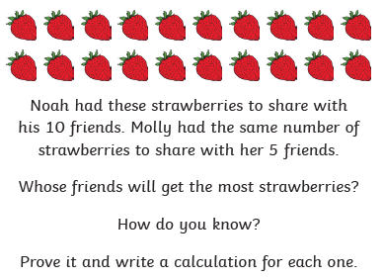
- Remember to use objects to help you solve these if you need to.
- Can you draw a picture to help you?

