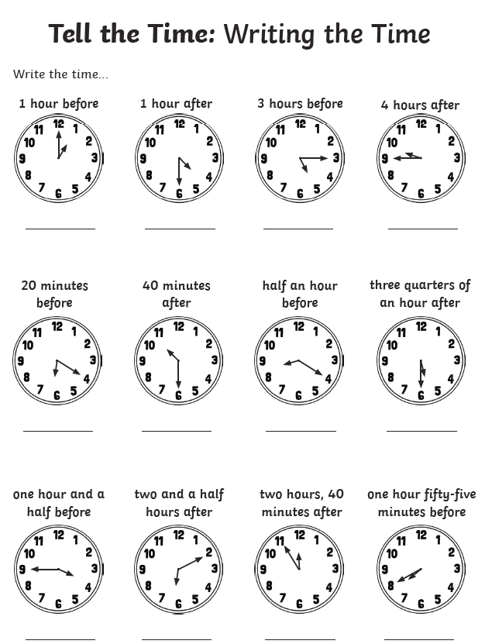
thirty five minutes before
30 minutes before
fifteen minutes after
twenty five minutes before
twenty five minutes after
ten minutes before
five minutes after
five minutes before
fifteen minutes before
fifteen minutes before
twenty minutes before
ten minutes after

