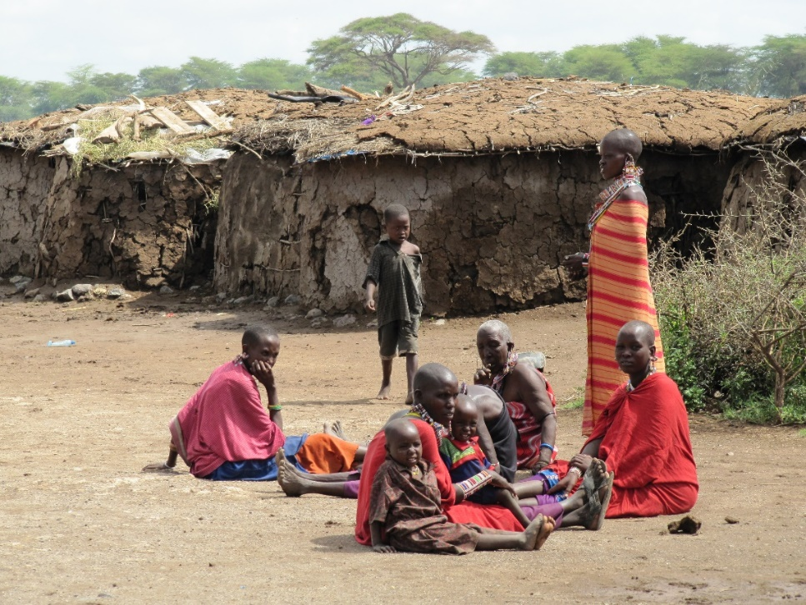

What is the same and what is different about these villages in Kenya and the UK?

Kenya

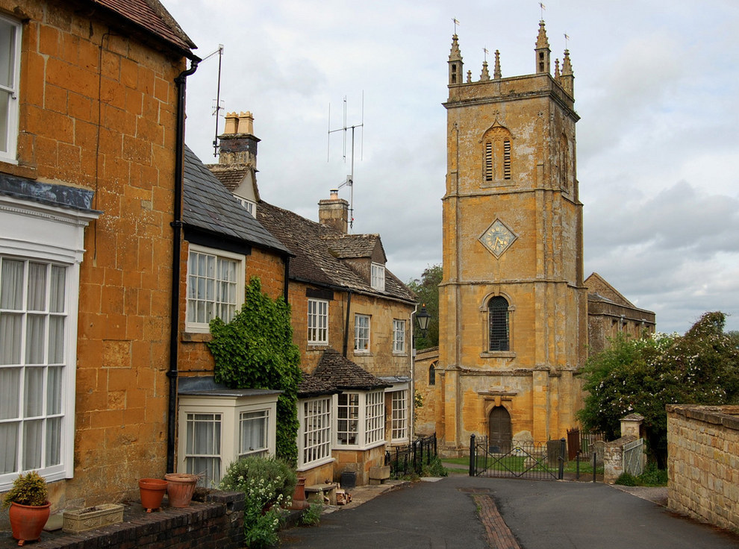

UK

Look carefully at these two pictures. This weekend, think about:
- The similarities between the Kenyan village and the village in the UK.
- The differences between the Kenyan village and the village in the UK.
- Think of some adjectives to describe both villages.
On Monday 1st March you will write some sentences about the two villages.

