My Hands
by Jo Peters
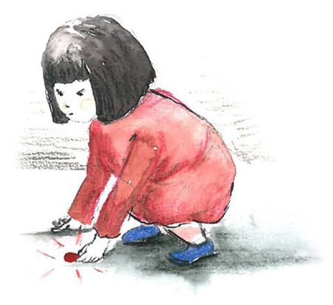
Think of all my hands can do,
pick up a pin and do up a shoe,
they can help, they can hurt too,
or paint a summer sky bright blue.

They can throw and they can catch.
They can clap the team that wins the match.
If I’m rough my hands can scratch.
If I’m rude my hands can snatch.

Gently, gently they can stroke,
carefully carry a glass of Coke,
tickle my best friend for a joke,
but I won’t let them nip and poke.

MY hands give and my hands take.
With Gran they bake a yummy cake.
They can mend but they can break.
Think of music hands can make.

