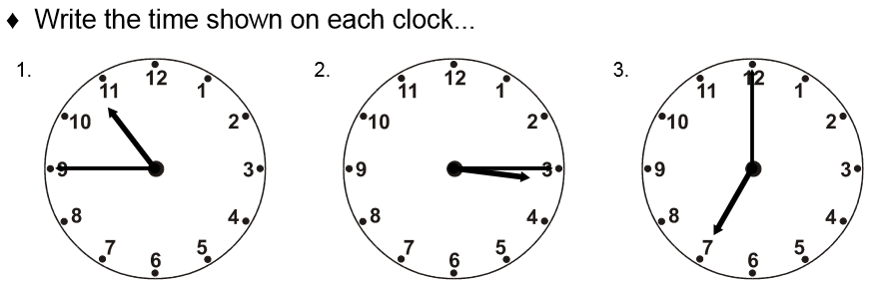
11.2.21 I can write the time in words.



