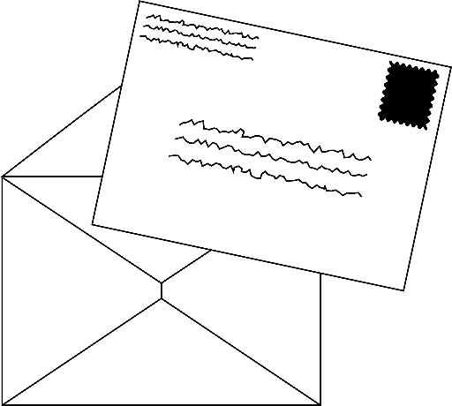

We have learnt more about the Great Fire of London this week and we met Samuel Pepys. For your Mighty Writing this weekend I would like you to imagine you were there at the time and think about how you would feel and what you would tell a friend or a family member if you wrote a letter to them.
This weekend use the attached document to help you with how you might feel and what you might have seen.
On Monday 24th January you will write a letter to a friend or family member telling them about the Great Fire of London!

How did you feel when you first heard about or saw the fire?




Add some words to describe:

How did you feel when the fire got worse?




Add some words to describe:

Did you help put the fire out? How?

How did you feel when the fire got worse?




Add some words to describe:

