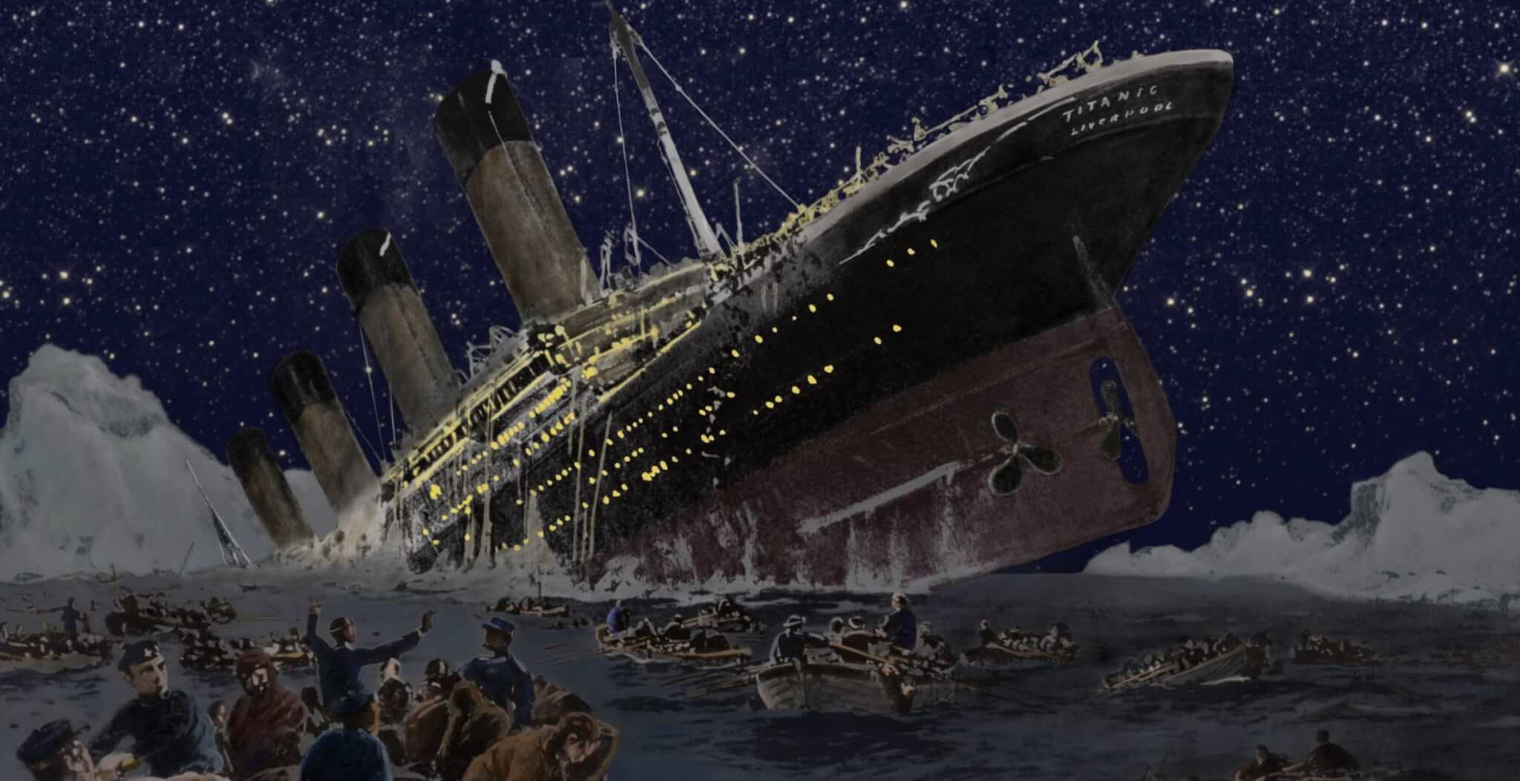
This weekend look carefully at this picture. Think about:
- What might be happening in the picture?
- What might the sea look like?
- What might the sea feel like?
- How might people might be feeling in this picture?
Think of some adjectives you might use to answer these questions.
On Monday 31st January you will write a description of what is happening in the picture as if you are telling the story.

