
Mighty Writing
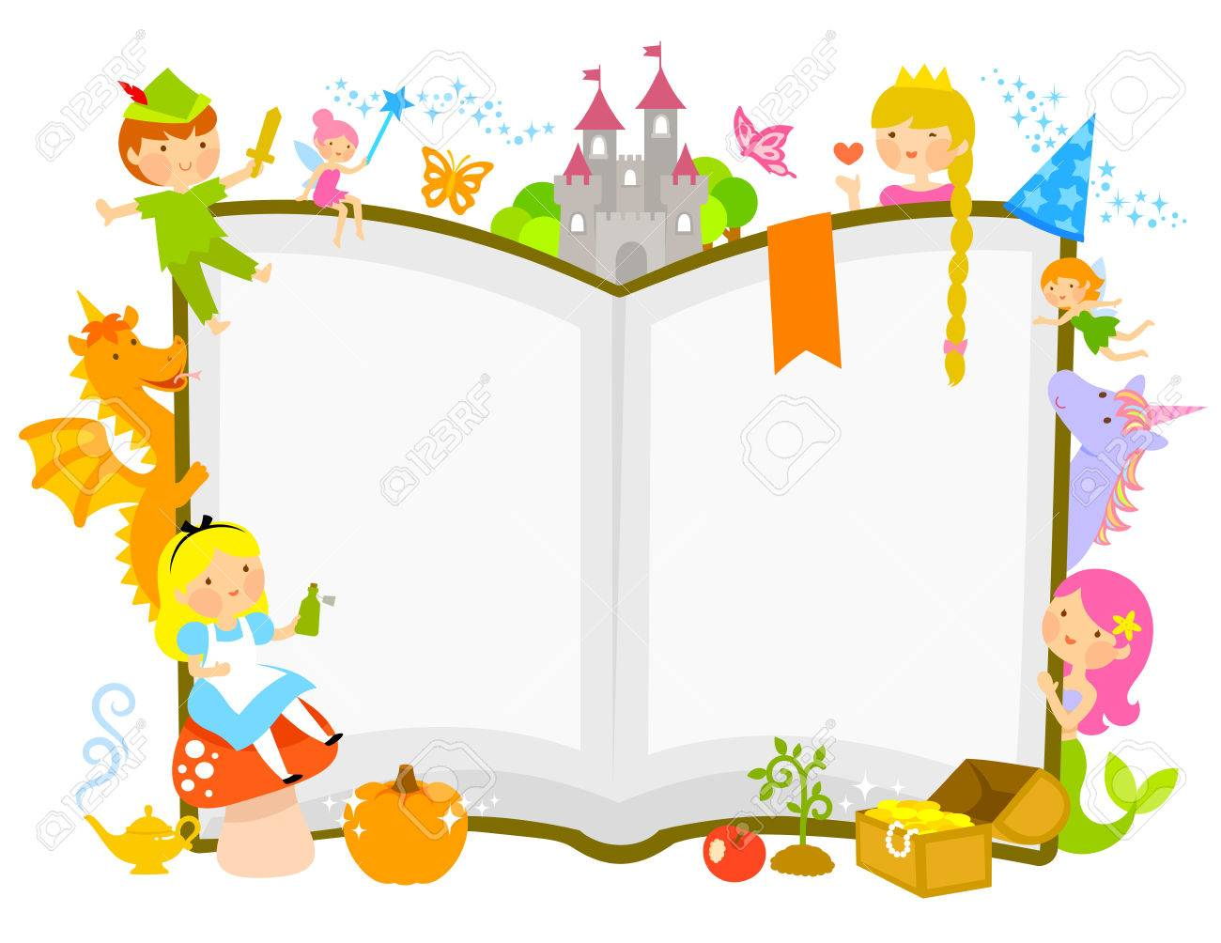
Our topic for this half term is Once Upon A Time. We will be reading, acting out, retelling and writing some traditional stories and fairy tales.

For Mighty Writing on Monday 11th January we will be asking the children to retell their favourite traditional tale or fairy story in their own words.

To help your child prepare for their writing you could:

- Look at some traditional tales and fairy stories together, discussing likes and dislikes.

- Help you child to choose their favourite traditional tale.

- Read the story together with them, talking about the characters, setting and plot.

- After reading the story, retell it verbally together with your child.

Remember, it must be a traditional tale or fairy story!

