Class 4 Homework - Mysterious Maya Civilisation Name
 | Maths | Literacy | Art / DT | History/Geography
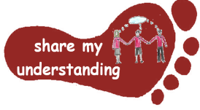  Share my understanding | Find out about the Maya number system. Explain how this system worked. Try writing some different number sentences using this system.  M1 | Read a Maya myth or legend of your choice. Then summarise what it is about in your own words.  L1 | Create a headdress in the traditional Maya style.  A1 | Create a timeline to show how the Maya civilisation developed over time.  HG1
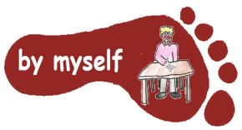  By myself | Explore the Maya maths games at: maya.nmai.si.edu/maya-sun/maya-math-game  If you can’t find this then try going on Google and searching ‘Maya maths activities’.  M2 | Read through ‘The Hero Twins’ story and then answer the reading comprehension questions.  L2 | Make a model of a Maya town or village.  A2 | Find out about one of the Maya settlements. Show where the settlement was on a map and share the information you find out about it.  HG2
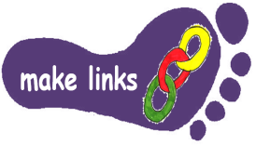  Make links | Work through the ‘Maya Number System’ sheet using what you have learnt about Maya numbers to help you.  M3 | Write an information leaflet about the Maya civilisation, sharing important facts about these people and their lifestyles.  L3 | Find out about Maya Codex and create your own Codex.  A3 | Find out how archaeologists and historians have found out more about the Maya civilisation over time.  HG3
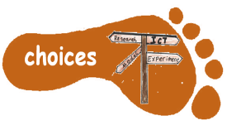  Make choices | Create your own Maya number problems for us to solve in class. Make sure you prepare an answer sheet so we can check our answers!  M4 | Find out about an aspect of Maya life which interests you. Write a non-chronological report to share what you find out.  L4 | Find out about the food Maya people ate. Try some of these food items at home.  A4 | Find out about a famous person from the Maya civilisation and create a fact sheet or Powerpoint Presentation about them.  HG4

Enjoy choosing and carrying out the tasks. I look forward to finding out what you have been learning at home.

