Happy new year 2021
Class 4 were all ready to start a new year and a new term at Upham school until they were all told that Boris was going to make another one of his announcements!!
Sure enough covid-19 was getting worse and the school was shut down for another lockdown!
Homeschooling begins
The children would once again have to go into home schooling!
The teachers worked very hard to make a home schooling plan for the children. And the children got ready for a term of home learning.
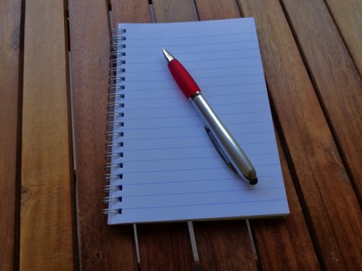
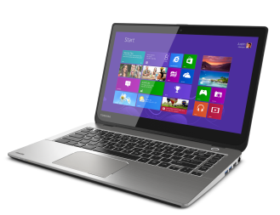
Cleaver Technology.
And so it began this time round it was slightly different because they were now able to go on online classes such as Google classroom and Google meets. Class 4 have been able to do online pilates sessions, P.E and online story times!
They also have been doing whole school assemblies witch everyone gets to take part in!
Great effort.
The children and teachers are all working hard and home learning is working well.
They all hope to see each other again soon, but in the mean time everybody needs to keep safe and stay positive.
By Amelia Rogers Class 4.

