Captivating Chichen Itza
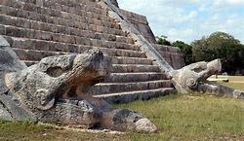
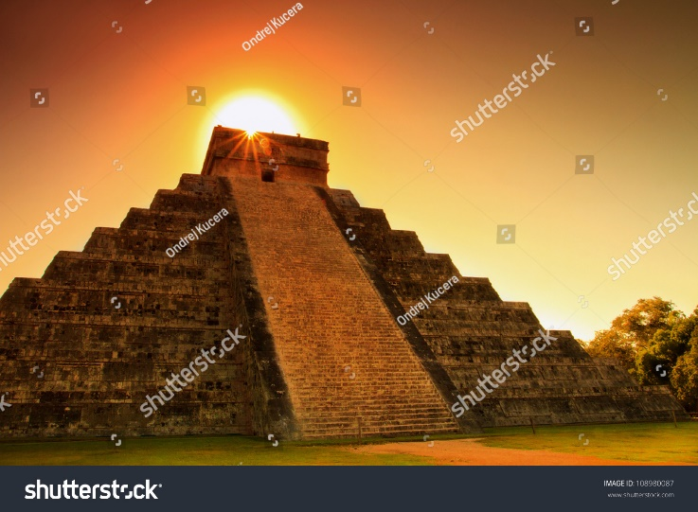
What are you waiting for? Come over to Mexico and visit Chichen Itza. Visit all the wonders there to offer.
There is a fascinating sink hole which is 27 metres deep and it is believed it was a place of sacrifice they have found Mayan jewellery and clothing.
Come visit Chichen Itza is the most beautiful temple in Mexico. It is aligned beautifully with the sun, so at sundown it looks stunning!
The temple has beautiful carvings and a 33-metre snake at the bottom of the temple.

