Chichen itza.
Deep in the heart of Mexico, you can find the Great city of Chichen itza. One of the temples El Castillo is a sight to behold. It is a huge tourist attraction and is sometimes considered one of the seven wonders of the world. 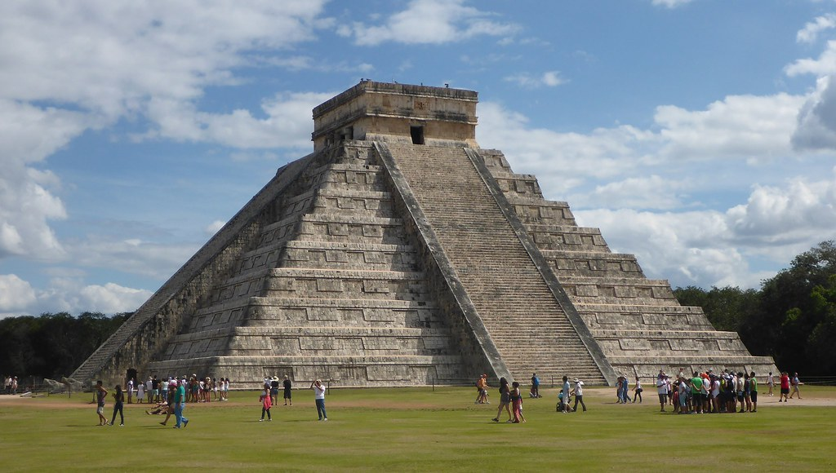

Lots of people who have already experienced this trip will often recommend it. Well it is an amazing trip and I would recommend it to any people who are looking for a holidays.

