Upham School’s Super Space Topic

This half term, in Class Four at Upham School, students have been learning about Space for their topic. They have also been learning about the space missions which have recently taken place.
Their homework this half term has been based on Space. They have really enjoyed the homework tasks set and the homework pieces they have created are fantastic. Some have designed a meal for astronauts thinking about the gravity in space and how they can eat it. They have also made Solar System models showing which order the planets go in from the Sun. They have used the resources that they have at home to create some amazing models. One of the models made even had facts about the planets on the back, which was a great idea. Some children also made model space buggies thinking about the gravity and terrain on the moon.
In class, they have even based their Maths on their Space topic. They have worked on worded problems linked to Space and created some for each other to solve. The students have really impressed their teacher, Miss Olver, with their fantastic Maths.
Class Four have also created lots of space artwork this half term. They have made space landscapes with mesmerising nebulas. To paint the stars, they used a technique called splatter painting where they tapped the brush so that the white paint splattered onto the paper like stars. They made astronauts and rockets out of paper and stuck these onto the black backgrounds.
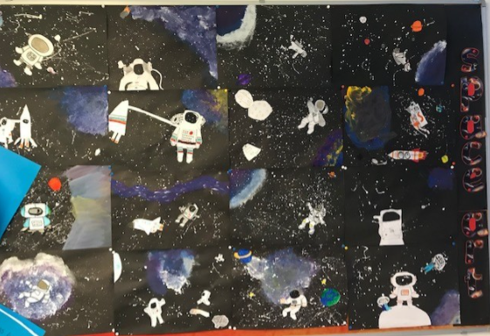
The pupils also wrote poems about space. These took a lot of planning, but turned out really well. They had completed a lot of work on similes, metaphors, personification and onomatopoeia and used this to help them with their poems.
The students have really enjoyed their Space topic and are excited to find out about their next topic in January.
By Max, Year 6

