Class 4’s Brilliant Brazil Topic

This term in Class 4, we have been learning about Brazil, including where it is, the different layers of the rainforest, the animals that live there, the city of Rio and the favelas.

We learnt about deforestation as part of our topic. We found out that some of the causes of deforestation are cattle ranching – this is where lots of people want beef and a consequence of this is that more trees are cut down for more space for cows. Did you know that only 5% of the trees which are cut down are because of logging? These trees are used to make fuel and furniture. Lucy in Class 4 said, “I liked learning about deforestation so I can try and help as much as I can’.

Everyone enjoyed making posters about deforestation in class, although it was quite heart-breaking to learn that 95% of the trees we cut down in the Amazon aren’t used. We also found out that 137 species of plants and animals become extinct every day and that some endangered species include giant otters, golden lion tamarin and jaguars. Louis, a pupil in Class 4, explained that he has very much enjoyed learning about the rainforest in Brazil.
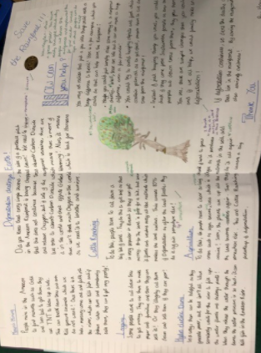
We also learnt about the favelas on the outskirts of Rio de Janeiro. They are the poorest towns in Brazil. We learnt about one called Rocinha in Rio, the name means ‘little farm’.

Overall, Class 4 have really enjoyed this topic. George from Class 4 said that he liked learning about Brazil because he didn’t know much about it and it was very interesting. Now Class 4 are looking forward to their next topic which will be all about space.
By Maia and Austen, Class 4 Pupils

