Class Four’s Fantastic Forces

This term Class 4 have been learning all about extreme sports and different forces that act when playing that sport.
The first investigation that Class 4 carried out, was a test to show how much friction acted on our shoes when we dragged our shoe along different solid surfaces. They found out how much pull was needed to move the show over the different surfaces using a Newton metre.
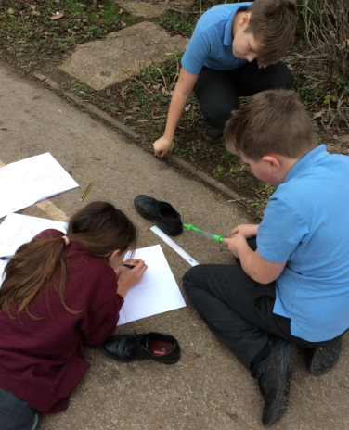
The next investigation Class 4 carried out, was how much air resistance was created on different surface areas. What they did was: they dropped pieces of A4 paper from the same height every time, but the paper was folded into eighths, quarters and halves. They timed how long it took to fall from a height to the ground. Some of the pupils dropped their pieces of paper from different heights, for example, some of the pupils decided to drop their paper from the challenge trail (climbing frame) and some from standing on the top of a chair.
The next test that Class 4 did, was a test to show how much upthrust is needed to keep an object afloat. They dropped different items of different mass and materials to see if it would float or sink. The children kept a tally to show how many stayed afloat and which ones sunk.
They did another test to see how much weight they needed to add to a foam pencil grip to make it sink. Every time they added a paper clip to the pencil grip it would go down a bit more each time. Just like the other experiments, the children kept tally of the scores. Each child was put into a group and in their little team they had to decide a way of attaching the extra weight. This was to represent a scuba diver carrying weight to sink under the water.
Class 4 have had a lot of fun doing all of these experiments and can’t wait to start learning and finding out about levers, cogs and gears in the future.
Written by Zac and Ethan (Pupils in Class Four)

