Chocolate Maths Problems

- Today, you are going to be making a Mexican Hot Chocolate Pudding Cake with Mrs Soley. Here is the ingredient list for 6 people.
Can you fill in the missing ingredients to show how much will be needed for different amounts of people?

6 servings | 3 servings | 12 servings | 600 servings
125g flour  100g sugar  32g cocoa powder  2tsp baking powder  64ml milk | 62.5g flour  _____________  _____________  _____________  32ml milk | _____________  200g sugar  _____________  4tsp baking powder  _____________ | _____________  _____________  3200g cocoa powder  _____________  _____________
(Think about how you can get from the original number of servings to the number of servings you need. You can only use the operations multiply and divide on this question)

- The average cacao bean (which the Mayans used to make their chocolate drink) weighs 3.5grams.
- How much do 5 cacao beans weigh?
- How much 10 cacao beans weigh?
- How much do 25 cacao beans weigh?
(You could use the short multiplication method for a), a place value grid method for b) and the long multiplication method for c))

- A group of Mayans need to take cacao beans from Mexico City to The Great Pyramid of Cholula. The distance is 125km. If they travel 25km per day, how many days will it take them to get there?
(You could try counting in 25’s until you reach 125)

- Xbaqulque is a Mayan farmer who grows cacao beans. He lives on a farm with his wife Ix Quelch.
His age is a cube number.
His wife’s age is a square number and she is 15 years younger than him.
How old are Xbaqulque and Ix Quelch?
(Try writing out your square numbers and cube numbers, then look for two which are 15 apart)

- A Mayan warrior drinks one cup of hot chocolate each evening. His cup holds 50ml of hot chocolate.
- How much hot chocolate does he drink in a week?
- How much hot chocolate does he drink in February this year?
- How much hot chocolate does he drink in a year?
(You can use the short and long methods for multiplication to solve these questions. If you’re not sure how many days are in a week/February/a year then you could research these facts to find out.)

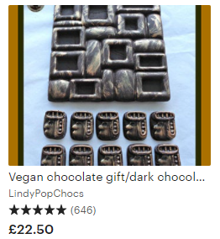
- You can buy Mayan themed chocolate on the Internet (I found this on Etsy!).

- If I buy one of these gift packs and pay with a £50 note, how much change will I get?
- If I want to buy 4 of these gift packs for presents for my family, how much will the total cost be?
- If the gift pack is reduced to half price in the shop, how much will 1 pack cost?
(You might find it useful to underline the key vocabulary in each question to help you work out which operation you need to use)

