Hello Class 4,
I am so impressed by you! Not only have so many of you taken up my challenges but you have done so well at them and now really seem to be confident in using commas. I hope you will enjoy my challenge this week. You will be able to show how good you are at using commas but all the sentences are based on chocolate – yummy!
I enjoyed making Mrs. Soley’s Mexican Hot Chocolate Pudding Cake; it turned out well and Mr. Kimble and I really loved eating it, although we didn’t have clotted cream. I will definitely make this one again.
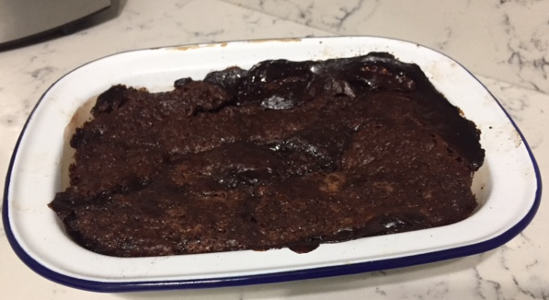
I hope you all have a good half term and that the weather will be good so we can get outside and have some fresh air and exercise after all that chocolate.
I’m looking forward to another half term of challenges after our break. I wonder what kind of SPAG I’ll use for the challenges???

