
Fossil Word Problems

- Mary Anning was born in 1799 and died in 1847.
- How old was she when she died?
- How many years ago was she born?
- How many years ago did she die?
(On these questions, you are trying to work out the difference between two numbers. The difference between when she was born and when she died or the difference between the year now and the year in which these events occurred. Think about which operation we can use to work out the difference between two numbers.)

- Mary Anning found most of her finds in Lyme Regis in Dorset. Lyme Regis is 88 miles away from Upham.
If I cycled from Upham to Lyme Regis at a speed of 8 miles per hour, how long would it take me to get there?
(The total distance is 88 miles. Each hour I cycle 8 miles. Think about how you can work out the number of hours it would take to do 88 miles.)

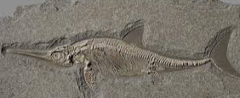
- When Mary Anning was 12 years old, she carefully dug up the skeleton of an ichthyosaurus. The skeleton was 5.2m long.
- How long was the skeleton in cm?
- How long was the skeleton in mm?
(There are 100cm in 1m. There are 10mm in 1cm.)

- The average weight of an ammonite is 25 grams.
- If Mary found 6 of these, how much would they weigh in total?
- If Mary found 15 of these, how much would they weigh in total?
- If Mary had collected a total weigh of 275g, how many ammonites did she find?
(For questions a) and b), you need to use multiplication to find the total weight as there is more than one ammonite. For question c), you need to use the inverse operation. The inverse of multiplication is …)
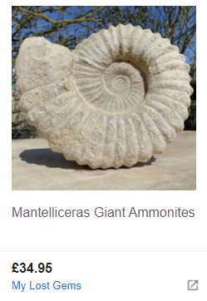
- You can buy beautiful ammonites. Here is one I found for sale online.
- If I had £100 in my bank account and bought this one, how much would I have left?
- If I decided to buy 3 of these for my friends, how much would it cost in total?
(For question a), it is very similar to working out how much change you would get if you bought something in a shop. Which operation do we use for working out how much change, or how much is left?
For question b), we are buying more than one of something, so we will need to multiply.)

