
Fossil Word Problems

- Mary Anning was born in 1799 and died in 1847.
- How old was she when she died?
- How many years ago was she born?
- How many years ago did she die?

- Mary Anning found most of her finds in Lyme Regis in Dorset. Lyme Regis is 88 miles away from Upham.
If I cycled from Upham to Lyme Regis at a speed of 8 miles per hour, how long would it take me to get there?

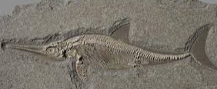
- When Mary Anning was 12 years old, she carefully dug up the skeleton of an ichthyosaurus. The skeleton was 5.2m long.
- How long was the skeleton in cm?
- How long was the skeleton in mm?

- The average weight of an ammonite is 25 grams.
- If Mary found 6 of these, how much would they weigh in total?
- If Mary found 15 of these, how much would they weigh in total?
- If Mary had collected a total weigh of 275g, how many ammonites did she find?
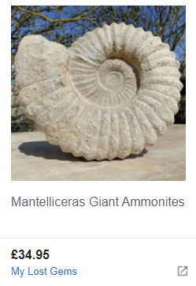
- You can buy beautiful ammonites. Here is one I found for sale online.
- If I had £100 in my bank account and bought this one, how much would I have left?
- If I decided to buy 3 of these for my friends, how much would it cost in total?

