My Mayan Fact Page
Have you ever wanted to learn about the who Mayans are? If you have read on to find out.
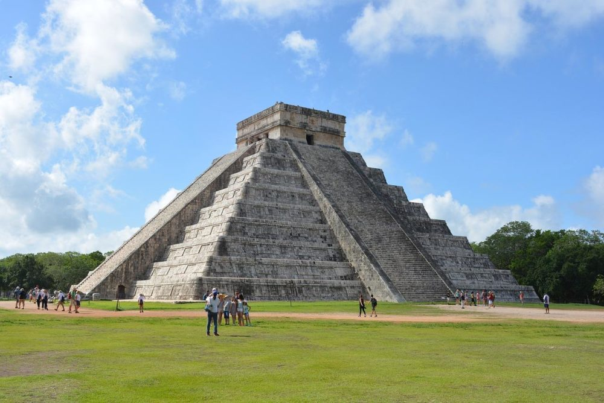
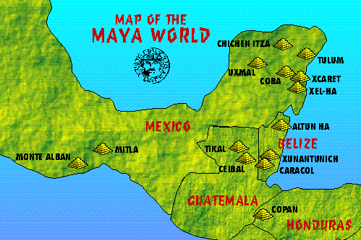
Sacrifices
The Mayans believed they had to offer blood to the gods to keep them happy. The blood was from animals or even people. They usually use the colour blue.
Food and drink
The Mayan’s main food was maize. They liked it so much that there was a maize God. They had other foods such as sweet potatoes and beans. They drank lots of chocolate.
Maya temples
The Mayas built lots of temples. Their most famous is Chichen Itza. They were built for the Gods. They are still being discovered and they are discovered by x-rays.
Where and when did they live?
The Mayans lived in Mexico in 1000 BC until 1697 CE when it is believed conflict between competing cities may have caused their collapse.

