Fantastic Mayan Farming!!!

The Mayans were excellent farmers. They used different types of farming for various types of ground. Their favourite thing to grow was maize, they even had a maize God! If you want to find out more interesting farming facts then read on...

What did they grow?
The Mayans grew so many things. They grew maize which was their equivalent of corn and many different vegetables such as potatoes, pumpkins, chillis, peppers and sweet potatoes. They also grew avocados and watermelons.

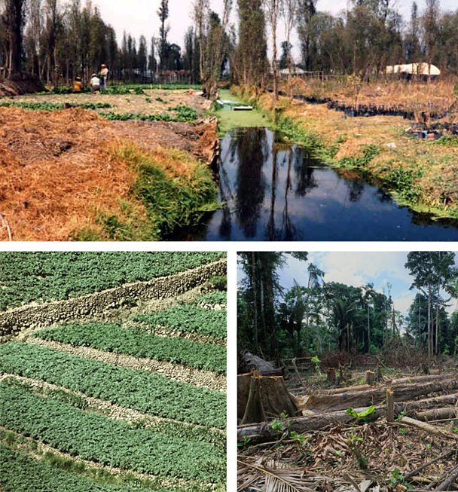
What methods of farming did they use?
There were three types of Mayan farming known as slash and burn, terrace and raised field.
- Slash and burn farming, also known as ‘shifting’, is shown in the bottom right photograph. They would cut down and burn parts of the jungle to grow their crops. The ashes from the fire gave the crops lots of nutrients. When the nutrients had all been used up, they let that part of the jungle regrow and found another spot to start again.
- Terrace farming is shown in the bottom left photograph. Walls were built to make small flat fields, one on top of the other. This method was useful for farming in mountainous areas.
Mayan Farms
- Raised farming is shown in the top photograph and was used for land that was very wet. They dug out canals and used the soil to raise the ground so they could grow crops there. They were also able to eat the fish that swam in the canals.

How did they know when it was harvesting time?
The Mayans were very clever. They developed the first calendars. Their calendars weren’t quite the same as the ones we have today, they only had twelve days in a month and were written on stone. They told them exactly when to plant and harvest their crops. They also told them when it was going to be rainy and when it would be sunnier again. This was really useful and explains why they were so successful at farming.

