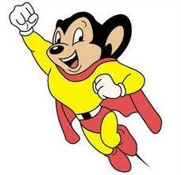
Planning sheet

How will the villagers feel?
How are the hunters feeling?

What happens in the end?
What might happen to the village?
Will your story have a sad or happy ending?
What might the villagers say to the hunters?

