What colours can you see?
What buildings and vehicles can you see?

Fun Fair at Daisy Nook 1953 By LS Lowry
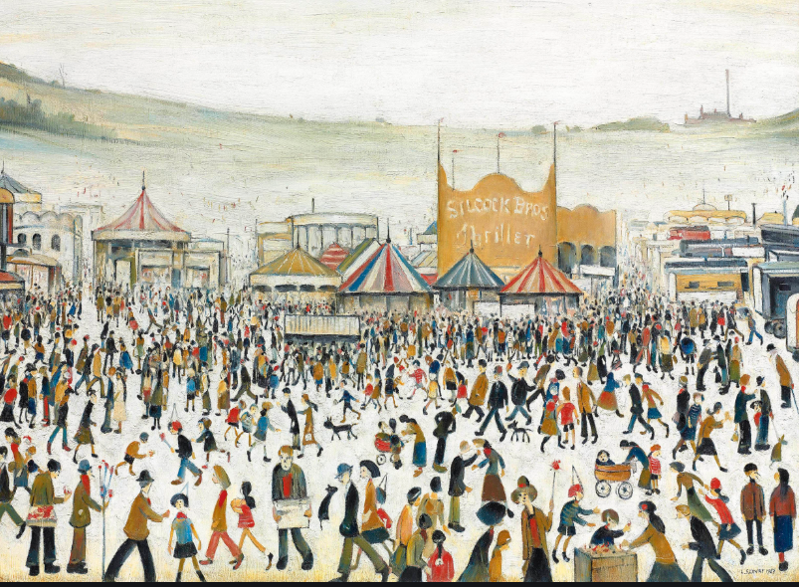
What are the people in the painting doing? There are lots of things, list them.
The people are at the fun fair how do you think they would feel?
This painting sold in 2011 for more than £3 million. The people selling it thought it would sell for £1.5 million. Why do you think it was so expensive?

