Complete the sentences using the following symbols: < > or =

30ml 60ml

1L jug Two half litre jugs

52L 25L

Order the results from largest to smallest:
500ml, 750ml, 250ml, 1L

Who has more pop?
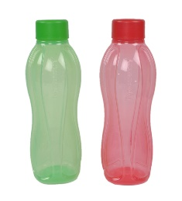

Eric I have these 2 bottles:
250ml 250ml
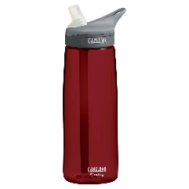

Sasha I have this bottle:
750ml

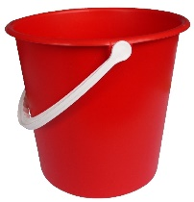
Sarah’s 1L bucket has a hole in it. She needs exactly 1L to water the plants. She has a 250ml measuring jug. Can she use this?

True or False:
The taller a container is, the more liquid there is.
Explain why you agree or disagree.

Work out these values:
40ml – 20ml =
20ml – 10ml =
10ml – 5ml =

What do you notice about these answers?
Why do you think this is happening?

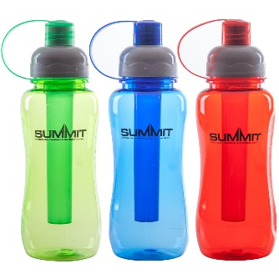
These 3 bottles each have more than 20ml of water in but less than 50ml.
The green bottle has 5ml more than the red bottle.
The blue bottle has 10ml more than the green bottle.
How much could each bottle have in?

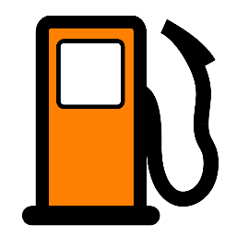
A petrol tank can hold 50l of petrol.
There is 12l of petrol in the tank.
How many more litres of petrol are needed to fill the tank completely?

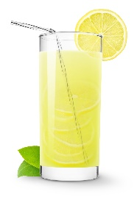
Holly makes some lemonade to sell.
She mixes 4 litres of lemon juice, 5 litres of sugar syrup and 17 litres of water.
How many litres of lemonade does she make?

