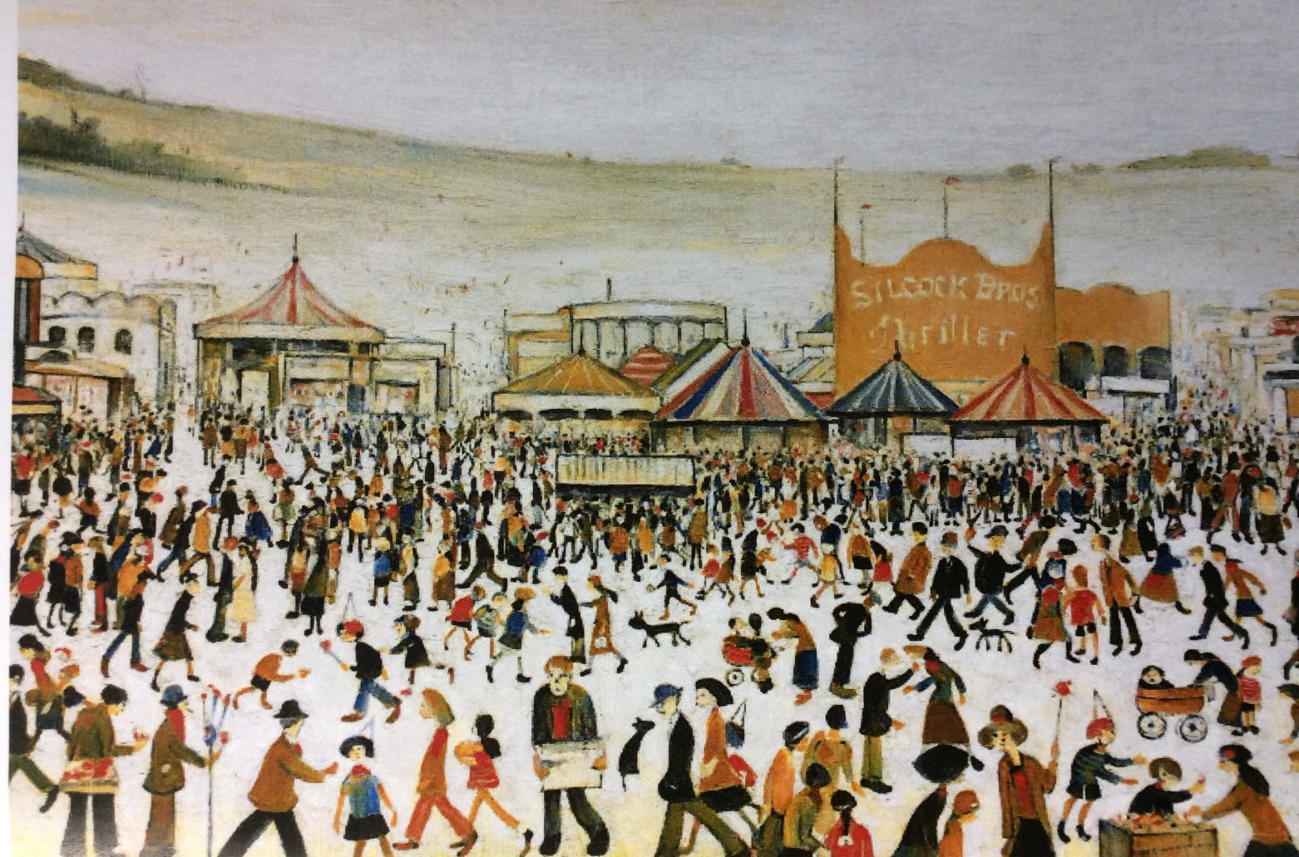
This marvellous masterpiece of the Modern British Art World could be yours!
Painted by LS Lowry in 1953, Fun Fair at Daisy Nook is a vibrant and interesting painting of an exciting day out at the fun fair.
Painted in Lowry’s distinctive style of stick people figures, people would instantly know you owned a Lowry, just think how jealous they would be!
Look at the all the colours, red, orange, yellow and blue - it would brighten any space, a hotel, home or office. So many interesting shapes, the stripy tents, the old fashioned caravans lined up at the side and on the hill in the distance, a factory just to remind us that we are near an urban area.
So much of interest in this art work, the crowd of people walking and talking, showing their friends what they have bought, holding their balloons, spending time with their children, eating toffee apples with dogs running through to see if anyone has dropped anything tasty.
The Thriller ride owned by the Silcock Bros encourages a smile on everyone who sees the painting as they remember their own experience of fair ground rides!

Come to the sale and buy yourself happiness!

