
Comment t’appelles-tu? Je m’appelle…
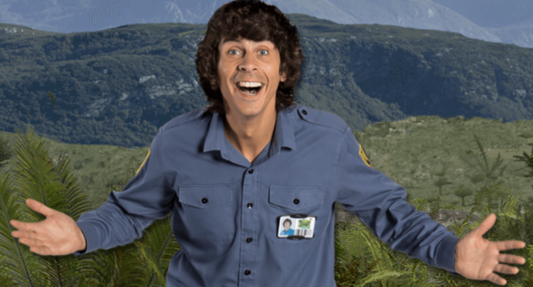

Je m’appelle ________________________________________________ Je m’appelle ______________________________________________________
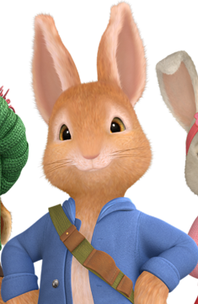
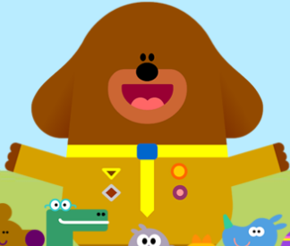

Je m’appelle ________________________________________________ Je m’appelle ______________________________________________________
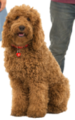
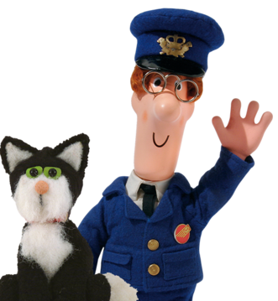

Je m’appelle ________________________________________________ Je m’appelle ______________________________________________________
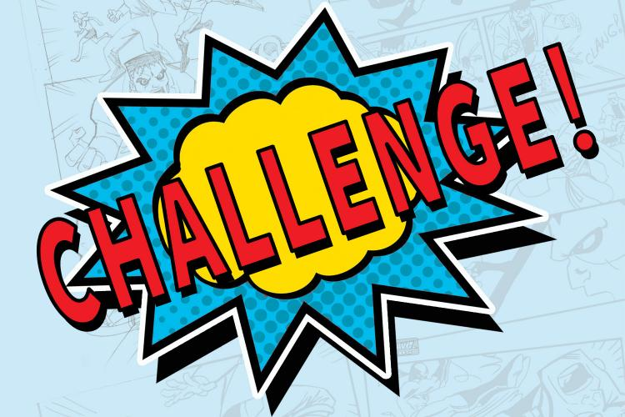

Comment t’appelles-tu? Can you write the answer in French below.

____________________________________________________________________________

