Images to show how God revealed himself in the Bible
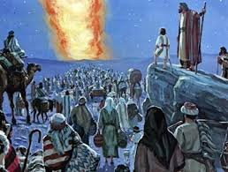
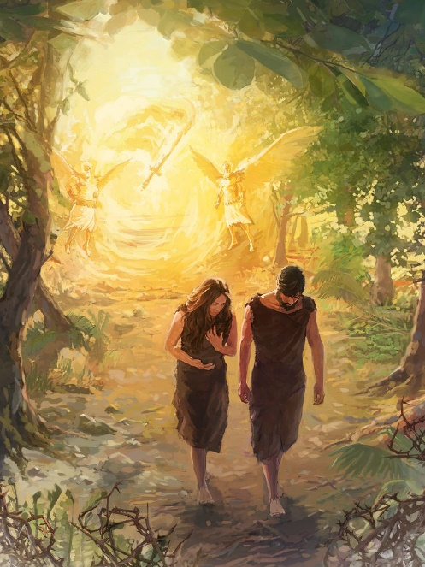

Genesis 3 v8
Then they heard the Lord God walking in the garden during the cool part of the day, and the man and his wife hid from the Lord God among the trees in the garden. But the Lord God called to the man and said “Where are You?”
Exodus 40 v38
So the cloud of the Lord was over the Holy Tent during the day, and there was a fire in the cloud at night. So all the Israelites could see the cloud while they travelled.

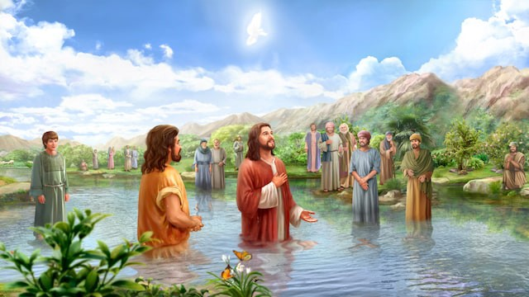
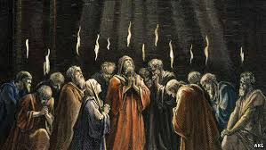
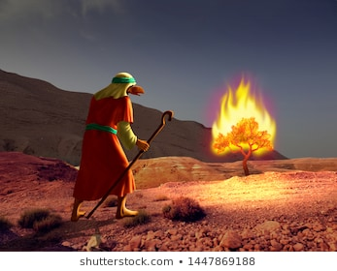
Luke 3 v21-22
When all the people were being baptised by John, Jesus also was baptised. While Jesus was praying, heaven opened and the Holy Spirit came down on him in the form of a dove. Then a voice came from heaven saying, “You are my Son, whom I love, and I am very pleased with you.
Acts 2 v3-4
They saw something like flames of fire that were separated and stood over each person there. They were all filled with the Holy Spirit.
Exodus 3 v2
There the angel of the Lord appeared to Moses in flames of fire coming out of a bush.

