Crosspoints

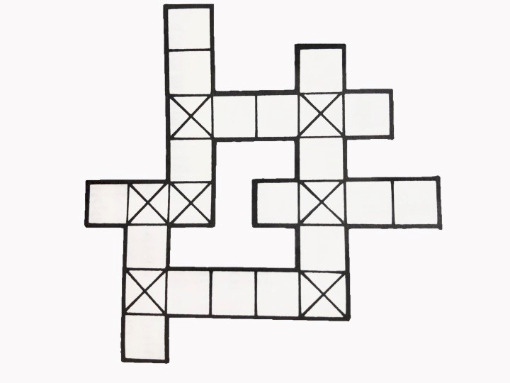
Fill in this grid with words of your choice. You gain points for certain letters. Different letters get different scores. A letter which falls on a ‘cross’ square is counted twice. How high a score can you get?
Letter scores Example
A-1 | N-2 |  | 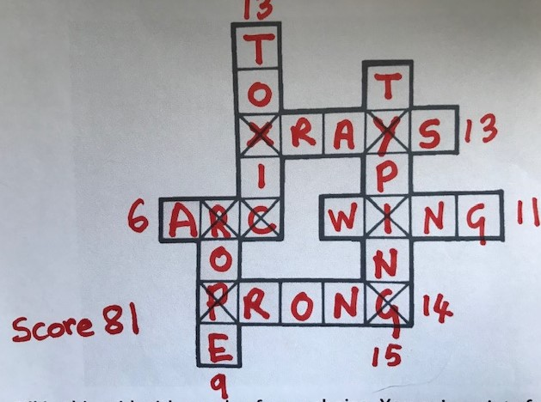
B-4 | O-2
C-3 | P-4
D-2 | Q-6
E-0 | R-2
F-3 | S-1
G-4 | T-1
H-2 | U-2
I-I | V-5
J-5 | W-4
K-4 | X-6
L-3 | Y-3
M-3 | Z-6

Crosspoint Grids

