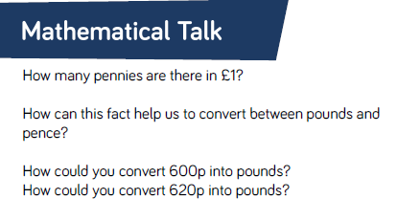
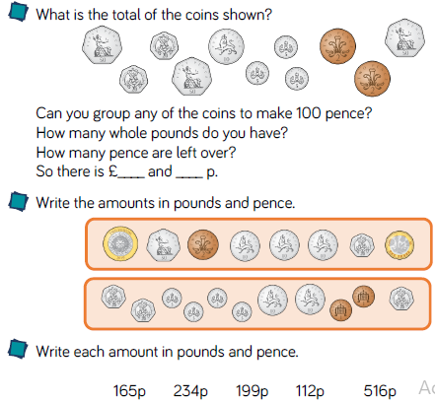

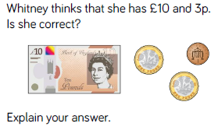

Grab a handful of coins. Count out how much you have. Write the amount in pence. Then change it to £ for example 129p = £1.29
You could play a game with someone at home to see who gets the most money each time.

