River Deep, Mountain High is a geography based topic. They will be developing skills in reading and understanding keys, co-ordinates and scales on various maps and learn to locate countries, continents, large mountain ranges and rivers on UK and World maps. They will learn to use atlases, the internet and Google earth to locate rivers and mountains of the world and establish facts. They will study the physical geography of mountains and rivers, examining how these features are formed. We are hoping to organise a visit a local river.

In maths, we will be learning mental and written methods for addition, subtraction, multiplication and division. There will be ongoing opportunities to solve problems in different contexts involving all four operations. We will continue with weekly times tables tests. Timetables.co.uk is a good website to practice alongside TT Rockstars.
Home Help- How you can support your child with this half-term’s learning?
Please encourage your child to read about mountains and rivers. The homework tasks are all linked to our topic so can provide a good starting point, but a trip to the library or some time spent browsing the internet will help to broaden your child’s knowledge and understanding and any reading about ‘disasters’ is bound to capture their imagination. We will also be writing adventure stories, so encourage your child to choose an adventure story to read at home. It would be helpful to discuss the setting and plot and look for examples of effective vocabulary.
If you have any queries about any particular task set on the homework grid, please come and speak to us.

If time and weather permit there is nothing that can beat practical experience. Going for a walk along a river and identifying features that you have read about in a book, or wandering to the top of a large hill (e.g. Old Winchester Hill or Butser Hill in Portchester) to experience the cold and wind, aching legs and fabulous views. This will aid their descriptive writing no end! Whilst having a bath or shower, chat about how the ‘steam’ is water vapour’ and that as water is heated it evaporates. Have they noticed the ‘condensation’ on the mirror? Can they explain why it’s there and why the water vapour (a gas) has turned back to liquid water? Can they take the temperature of their bath?

Key vocabulary linked to our topic. It would be useful for your child to be able to read, spell and understand the meaning of these words:
River, meander, source, mouth, waterfall, meander, valley, stream, tributary, flood, estuary, delta
Mountain, range, summit, peak, snowline, glacier, tree line

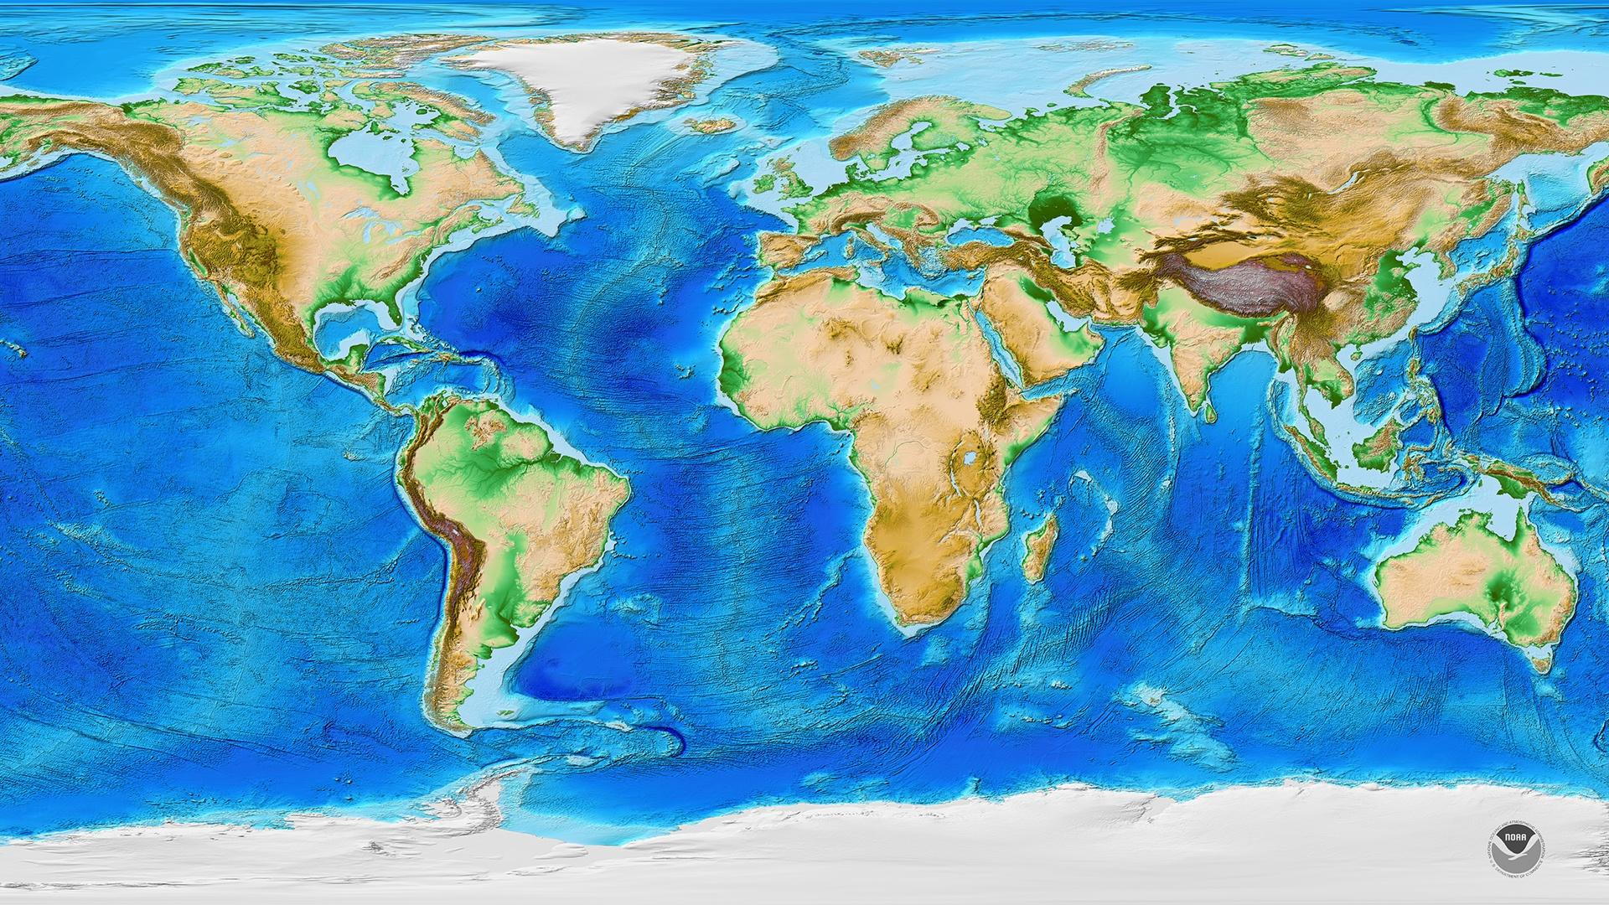

As part of their consideration of what equipment and materials would be necessary on a mountaineering expedition, the children will develop their ‘Design and Technology skills’ designing and making a hat suitable for colder climates.
Listen to Me continues with the children learning the violin. In PE, the children will continue to go swimming each Wednesday. During our Friday sports lesson, the children will work with Mrs Harmer to develop their ability to play netball. We will also be preparing for our Christmas production.
In RE we will be thinking about Christians beliefs surrounding the Trinity.

In science the children will study the water cycle, learning to use and understand terms such as ‘evaporation’ and ‘condensation’. They will develop their understanding of solids, liquids and gases and learn to use a thermometer in order to read and record temperature accurately.

In science the children will study the water cycle, learning to use and understand terms such as ‘evaporation’ and ‘condensation’. They will develop their understanding of solids, liquids and gases and learn to use a thermometer in order to read and record temperature accurately.

River Deep, Mountain High is a geography based topic. They will be developing skills in reading and understanding keys, co-ordinates and scales on various maps and learn to locate countries, continents, large mountain ranges and rivers on UK and World maps. They will learn to use atlases, the internet and Google earth to locate rivers and mountains of the world and establish facts. They will study the physical geography of mountains and rivers, examining how these features are formed.

Class 3 Autumn 2
River Deep Mountain High!
English The children will read extracts from the diaries of mountaineers and examine the structure, style and organisation of these texts. They will then write their own diary extracts as if they themselves were on an expedition! They will also develop skills in writing adventure stories, for an imagined mountaineering disaster. They will focus on how they can use description of settings to paint a picture and elicit the desired reaction from their readers, using powerful vocabulary and a variety of sentence structures to capture and maintain interest.


