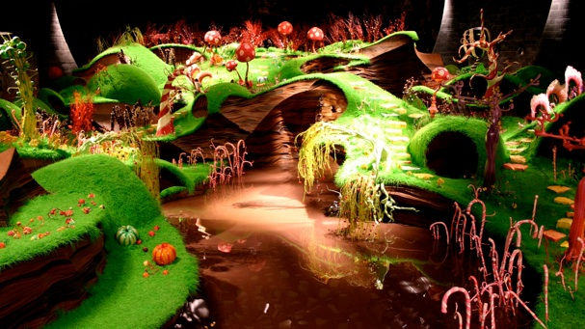
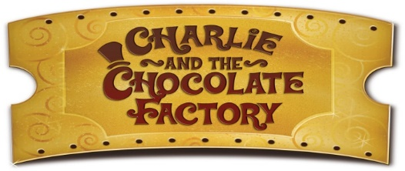
Class 3 Learning Spring 2 2025

This half term’s topic provides many opportunities to examine and develop skills in narrative writing. We will examine how Roald Dahl paints pictures with his vocabulary choices then apply this to write exciting descriptions of our own. We will read poems from the book looking at rhyming structure.

We will also look at the structure, organisation and vocabulary used in recipes, then design and write our own recipes for a brand new sweet or chocolate product. We will make nets and create a design to produce packaging suitable for the product they have made.
In Science we will be classifying materials as solids, liquids and gases and looking at the properties of these. They will investigate what happens when solids and liquids are heated or cooled and investigate which type of chocolate melts the quickest. In geography, we will be finding out in which countries cocoa is grown and the climatic conditions required. We will learn how cocoa is produced in Ghana and investigate the lives of farmers producing Fairtrade cocoa.
In PE, the children will be developing skills in Tag Rugby and focussing on body shape, rolls and balances in gymnastics. Our Listen to me lessons will continue to focus on the recorder. In RSHE, we will be exploring the theme of friendship and in RE, we will focussing on the events on Maundy Thursday and thinking about why Holy Communion is important to Christians during Easter time. We will be learning some vocabulary related to food in our French lessons this term. In computing we will be using the program Scratch to write a program to make a simple game.

How you can help at home
Please support your child in completing the topic homework activities. These can be handed in as you go along. Keep up the good work with supporting your child to learn their times tables facts. We have the timetables Rockstars subscription but there are many online resources that can help. Old fashioned flashcards also work well! We will continue with our weekly times tables tests every Tuesday. Each Friday we’ll send home spelling sentences. Little and often works best to learn these effectively.
Please read daily or talk about what has been read. with your child. If they have not got a scheme book from school, children can read any texts. A variety of genre and mix of fiction and non-fiction is ideal. Take time to chat about the structure and organisation of texts as well as the rich and varied vocabulary suitable for different genres to help develop your child’s understanding. To support our learning in science, look for examples of solids, liquids and gases around the home and explore what happens when materials are heated or cooled.

