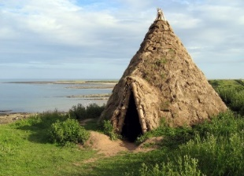
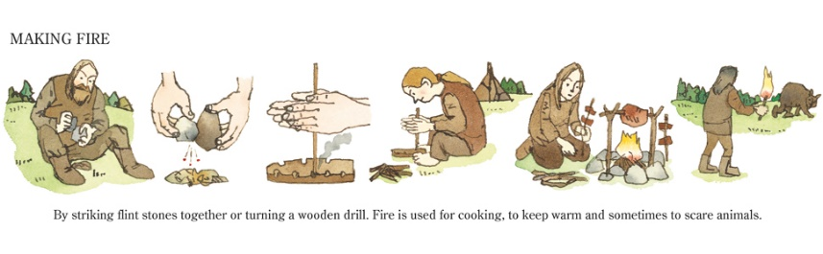
Hedgehog Class Autumn 1 Stone Age to Iron Age
Our first topic is history based; covering a very long period of time from the Stone Age to Iron Age. We are kicking off the topic with an exciting trip to Butser Ancient Farm where the children will experience at first-hand what life would have been like for people during this period. Back at school, we will use artefacts and secondary sources of information to learn more about homes, tools, food and farming.
In English, we will consolidate essential skills of handwriting, sentence punctuation and phonic knowledge. Extended pieces of writing will initially focus on recounts and non-fiction writing linked to our topic. Reading books about the Stone Age will help your child immerse themselves in the topic and develop a deeper knowledge and understanding to aid their writing. We will read Stone Age Boy and ‘Stig of the Dump’ as both books link with a character who ‘falls’ into the Stone Age. The children will compare the books and characters and think about how the authors use language effectively.
In maths, we will begin with consolidation and development of Place Value knowledge and work on ‘Number’. This includes ordering and recognising numbers, identifying the value of each digit in a number and counting on and back in different amounts. Later this half term we will move onto addition and subtraction.
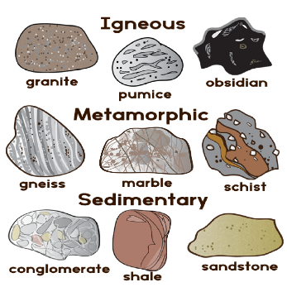
Our Science learning, will be the study of rocks, soils and fossils; discovering how these are formed; grouping them according to their appearance and properties and carrying out practical tests to investigate their properties. In art, the children will explore the use of chalk and pastels to recreate cave paintings in their own style. Our computing content will focus on the use of a Word processing program to create documents and communicate using text and images.
In other curriculum areas, we will be studying the Creation story in RE and thinking about how we can take care of our amazing world. We will have our regular sports coach on Fridays to help the children develop skills in football. The children will also be going swimming. Listen to Me lessons will give the children an opportunity to learn to play the toots (mini flutes).
How you can help at home
Please encourage your child to read daily. All children can read books selected at school or those from home. Some children will also be given a Little Wandle scheme book which will be changed weekly and a reading record to record what has been read. A visit to your local library to find a non-fiction book about our topic would also be very helpful. For less confident readers, daily reading will make a big difference to progress. For competent readers, discuss the content of books read at home.
In our class, it is important that the children work on the speed and efficiency of times table knowledge. Starting soon, there will be a weekly tables test on a Tuesday. We will continue to send home weekly spelling sentences to practise. Words will be tested each Friday.
Please support your child in completing the topic homework activities from the grid, selecting those .

Important dates
Butser Ancient Farm Trip- Tuesday 23rd^{t} September Swimming Lessons- Start Wednesday 24th September and then continue each Wednesday this term. A letter will be sent out shortly with more details.

