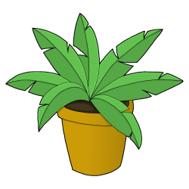
Class 3 Summer Term 1 2025
Plants
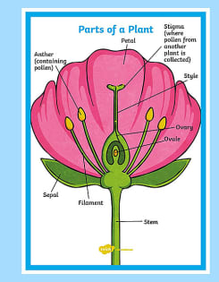
During our Science topic this term, we will be learning all about the life of plants. The children will explore the plants growing in various habitats in the school grounds. We will be carrying out practical work to investigate the factors that affect plant growth, looking at the life cycle of plants including seed production and dispersal and considering how plants are adapted to their environment. The children will learn how to write a scientific report to record their findings.
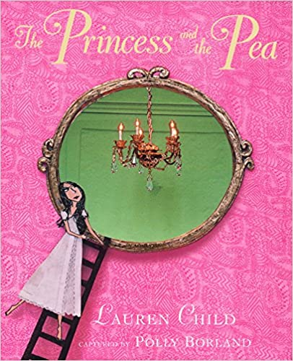
Linking to our topic, in maths the children will be learning skills to help with data handling; reading and interpreting different types of graphs, answering questions and plotting their own graphs of plant growth when carrying out the science investigations.
In English, we will be reading some Traditional tales. The children will look at story language; consider ways to extend sentences, building up to writing their own story ready to read with a younger pupil in our school. We will be using a range of non-fiction text to carry out research about plants.
In art, the children will be using the i-pads to experiment with photography of plant life. We will be playing summer sports in PE, including tennis, rounders and athletics. The children will also be working on dance moves linked to the theme of growth. In Listen to Me, the children will be playing Samba drums
In RE, we will explore the theme of ‘Devotion’ with particular reference to the Hindu faith. We will discussing risk and how to stay safe in our RSHE lessons. In French , we will continue to develop vocabulary linked to food – in particular fruit and vegetables.
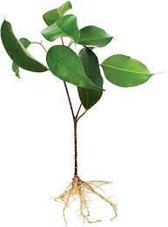
How parents can help at home
At home, it would be great if children can help in the garden; what do the plants need to grow well? What different species of plants are growing in your garden and in the local area? Could they plant some seeds and watch them grow? Can you find any fruits or seeds on plants you find? There are several different activities to choose from on the homework grid related to our topic.
Children should be continuing to read on a daily basis. This could be fiction or non-fiction. Perhaps they could revisit favourite Fairy stories and discuss the language, plot and characters in these. A plant identification book would be helpful in naming a variety of plants in the local area.
To support our work in maths, give your child the opportunity to use money in real life contexts, for example adding amounts, and working out the change when shopping. We will continue to have weekly times tables tests this term, so keep up the good work with regular practice at home. www.timestables.co.uk is an excellent website to practise these with a range of games and quick fire questions in the speed test, together with TT Rockstars. Our weekly spelling sentences will be given out each Friday, ready for a test the following week. Thank you for your continued support at home.

