Hedgehogs Class Summer 1 2026
Ancient Egypt

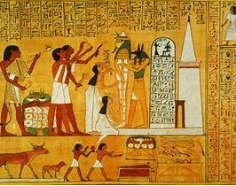
Our History based topic this term will start by thinking about the chronology of the Ancient Egyptian period. Later on the children will be entering “Tutakhamun’s tomb” and discover some of the treasures inside. We will read extracts from Howard Carter’s diary and think about what can be learnt about life in Ancient Egyptian times from artefacts from the past. We will learn about everyday life, the importance of the river Nile and carry out research about Egyptian gods and goddesses. The children will use maps to locate Egypt and find key features of the country.
In English, the children will read and write diary entries related to The Diary of a Killer Cat by Anne Fine and think about features of diaries. They will write their own story diary about a pet. This will lead to reading diary extracts written by Howard Carter’s to describe his discovery of Tutankhamun’s tomb. Then we will read ancient Egyptian myths and participate in role-play to retell stories. They will read a range of non-fiction related to the topic and write informative texts using technical vocabulary and features such as sub-headings and diagrams. Our topic will culminate with an Ancient Egyptian feast – more information to follow.

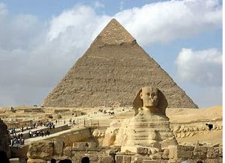
In maths, the children will be learning about decimals, including in the context of money. We will continue to consolidate understanding of all four operations and place value, with regular opportunities to solve a range of problems in different contexts. Our learning will then move onto the topic Shape.
Our art topic this term will be to design and make a clay Egyptian cartouche. We will also be making Egyptian flat bread and hummus ready for an Ancient Egyptian feast later this half term.
The instrument we will be learning in Listen to Me this term is the trumpet. In PE, we will be enjoying athletics, rounders and creating Egyptian dances. In RE we will learn about Jesus calling the first disciples and read bible stories including the Good Samaritan within the concept of community. During our RSHE lessons we will think about how to keep our bodies clean and healthy.
How you can support your child with this half-term’s learning?
Please encourage your child to read about The Ancient Egyptians. The homework tasks are all linked to our topic so can provide a good starting point, but there are many other opportunities to find out more using the internet or books from the library. If you have any queries or would like clarification about any particular task set on the homework grid, please do ask.
Children should be reading daily, aiming for a variety of different texts, both fiction and non-fiction and having opportunities to discuss the content of what they have read. If reading a non-fiction text about the Egyptians, encourage your child to use the index, contents and sub-headings to help locate the information.
The children have been working very hard to learn their multiplication tables. The Year 4 children will be doing the Multiplication tables test later this term. Please keep up the good work at home on timestables.co.uk, Timestables Rockstars, flashcards, etc. Regular practice makes all the difference. Likewise, little and often works best when learning the weekly spelling sentences.

