Class 3 Home Learning tasks Summer Term 1 2026 Ancient Egypt Name
 | English | Maths | Topic
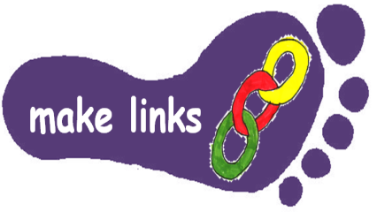 | Find out at least 10 weird and wonderful facts about the Ancient Egyptians. Make an exciting and eye catching Power Point to share with the class. | Make your own pharaoh top trumps cards, scoring things like wealth, power, treasure etc.  Play your top trumps with someone in your family. | The Ancient Egyptians were famous for their burial rituals. Find out how to mummify an orange and carry out the experiment. Follow the link to the activity sheet. You will need to start this early on!  http://www.yac-uk.org/activity/mummify-an-orange
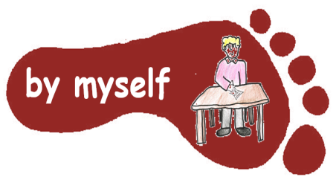 | Choose a myth from ancient Egyptian times. Turn it into an eye-catching cartoon strip. | Write a set of worded problems using the four operations (+ - x ÷ ) Use Ancient Egypt as a context for your problems. Remember to make an answer sheet for your problems too.  Example; If it took 2000 people 9 years to build a pyramid, how long would it take for 6000 people to build the pyramid? | Make a piece of art to represent an aspect of Ancient Egypt.  This could be a drawing, painting, collage, model, mask, piece of jewellery...you decide!
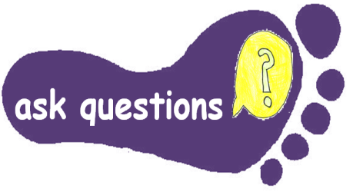 | Choose 2 different books about Ancient Egypt.  Read the sections that grab your attention. Discuss with an adult what you have discovered to answer Who? What? Where? When? Why? | Check out the games, challenges and activities on the Great Egyptian Number Challenge  http://www.childrensuniversity.manchester.ac.uk/learning-activities/history/ancient-egypt/the-egyptian-number-system/ | Find out what the Ancient Egyptians ate. Was it delicious? Would you find and eat those sorts of things for your meals?  Make a dish to bring in for our Ancient Egyptian feast in the last week of this half term. (Date to follow soon!)
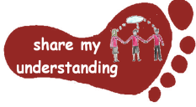 | Write an information page about one aspect of life in Ancient Egypt.  Include features to help the reader locate information eg sub-headings, captions for pictures, fact boxes | Have a go at the ‘Number Pyramid’ problem on the enrich maths website http://nrich.maths.org/2281 and answer the questions. If you are up for a more challenging task follow the links to ‘More Number Pyramids | Find out about what ancient Egyptians wore.  Make a costume to wear at our Ancient Egyptian feast in the last week of term.  (Date to follow soon)
Please do 5 activities from the grid – aim to spend at least 30 minutes on each activity, although some of the practical activities may take more time.
Make sure you do at least one task from each subject area. Colour the grid as you go, to keep track of the tasks you have done. If the task is practical, ask an adult to sign in the box to show you have completed it. Please hand homework in regularly. You will need to complete your tasks by Wednesday May 20th

