 | Science | Literacy | Numeracy / Computing | Creative
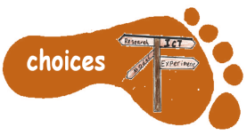 | Choose someone who has been influential in the development of computing, technology or the internet e.g. Tim Berners-Lee, Grace Hopper, Sir James Dyson, Research this person, and choose a way to present the information. | Evaluate the cover of The Iron Man. What do you like? What don’t you like?  Design a new book cover for the book. | https://nrich.maths.org/2404  Investigate different robot monsters you can make using the pieces.  Design your own robot using different length body parts. | Make a junk model of a robot you invent yourself.
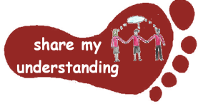 | Find out how magnets are used for different purposes around the home. Take photographs and label these to show what you have found out. | Read some poems about robots. Which do you like?  Write your own robot poem. | Use the program Scratch  https://scratch.mit.edu/download/scratch2  to make up your own game or quiz. Ask a friend to play your game and explain the algorithm you used. | Choose some music and make up a robot dance. If you want to, this could be with other children from our class. You could film your dance to show us.
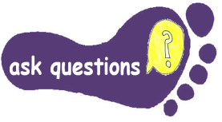 | Visit Winchester Science centre. Look out for exhibits that help develop your understanding of electricity and magnets. Ask questions and discuss your ideas. | Do some research at the website https://www.switchedonkids.org.uk/  To find out about how to be safe with electricity. Make a poster to inform children about staying safe with electricity. | Write some worded problems using a mix of addition subtraction multiplication and division using Robots or The Iron Man as a theme.  Don’t forget to write your answers. | Invent your own robot and describe what it does.  Draw a picture and label its special features.
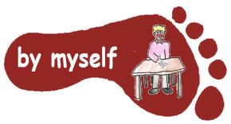 | Look at a toy or simple device eg a torch that uses a battery. Find out about the components in the device and how they are connected. Draw a diagram to show the circuit. | Write a short adventure story featuring a robot. | Try Chippy’s journey, a maths investigation using knowledge of compass directions and measure.  https://nrich.maths.org/2813 | Design and make a game that uses magnets. Write instructions for your game.
Class 3 Home Learning Robots / The Iron Man Spring 2026
This homework is for the whole of the Spring Term. Please do 4 activities from the grid by Wednesday 11th February. Do another 4 by Wednesday 25th March Some tasks will take longer than others; an approximate guide is 30 minutes – 1 hour per activity. Please label written work with your NAME. If it’s practical task, just a signature from your parent on the grid is great. Parents, thank you for your support with the home learning tasks. Please come and speak to one of us if you have any questions regarding homework.

