Class 3 home learning tasks Light and Dark Name
 | English | Maths | Other curriculum areas | Science
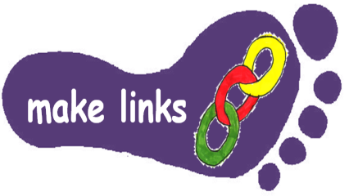 | Visit a fireworks or Christmas light display  Describe this using creative language. | https://nrich.maths.org/7044  Light the Lights investigation | Watch the dance created using glowsticks  https://www.youtube.com/watch?v=GdCZFh2bRtc  Plan, practice perform and film your own dance | Take photographs of different shadows.  How many shapes can you find? Count and record the types of light sources in your home. How can you change the size of a shadow?
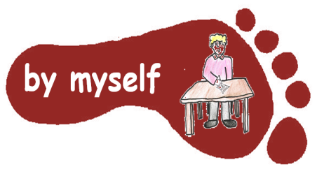 | Write a short mystery story about something that happened on a dark night. | https://nrich.maths.org/1014  Flashing lights investigation  (This one is more challenging) | Design and make a Christmas lantern that could hold a tea light. | Try some of the optical illusions at this website:  https://www.optics4kids.org/optical-illusions
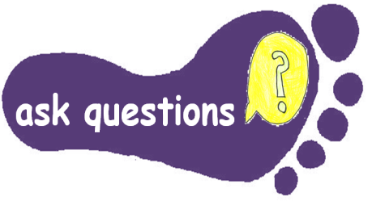 | Make a list of as many words you can think of that are connected to ‘light’. Make a wordsearch or a crossword with the words. | Maths: write some light themed worded problems involving addition, subtraction, multiplication and division.  Make sure you write an answer sheet to show the calculations. | Find out about how different religions light as a symbol for example the Jewish festival of Hanukkah, the Hindu festival of Divali, or how Jesus is thought to be the light of the World. Draw pictures and write about what you’ve found out. | Write a quiz about light, dark, reflection and shadows.  (It would be better to do this towards the end of the topic so you can demonstrate what you have learnt).
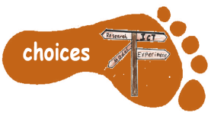 | Read a non-fiction book about light and dark you have or from the library. Talk about what has interested you with someone at home. | Make a pinhole camera. Instructions can be found on the internet. https://nrich.maths.org/8041  Investigate how to change the image. | https://www.bbc.co.uk/food/recipes/stained_glass_window_09846  Make stained glass biscuit decorations | Read the information about light at this website https://www.bbc.co.uk/bitesize/articles/zrs62v4#z2kssk7  Do the activity and quiz at the end of the page.
Do FIVE activities from the grid – aim to spend about 20-30 minutes on each activity. Please complete all tasks by Tuesday 16th December. Aim to do at least 1 task from each subject area. If the task is practical, ask an adult to sign in the box to show you have completed it. Please NAME all work you hand in.

