 | History / Science | Literacy / Numeracy | Art / DT /ICT
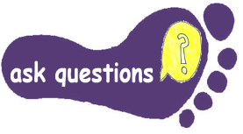 | Visit Stonehenge or  Avebury Stone Circle  Think about some questions you want to  find out on your visit. | Prepare a set of questions that would like to find out about The Stone Age, Bronze Age or Iron Age. Use the internet or a library book to answer your questions. Make a poster or a Powerpoint presentation to share what you have found out. | Think about how Stonehenge was built. What questions do you have about how it was built?  Make a model of Stonehenge or your own design of Stone Circle. Helpful hints at this website  http://downloads.bbc.co.uk/history/handsonhistory/ancients_circle.pdf
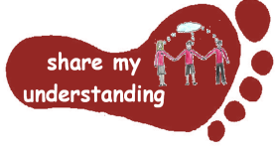 | Carry out research about how fossils, rocks or an aspect of the Stone Age, Bronze Age or Iron age that interests you.  Write a quiz using information you have found out. (Remember to write the answers too!) | Create a leaflet for ‘How to survive the Stone Age.’ Imagine you are transported back to the Stone Age and need a guide to help you survive. What would the guide say? What tips would it have? Use ICT, if you wish. | Prehistoric people ate mostly food made with plants.  Try gathering Autumn fruits eg apples and blackberries. Make Stewed Fruit with adult help.
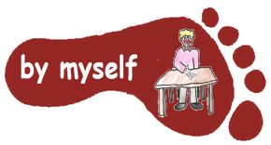 | Make a fact booklet to tell the class about your visit. If you can, include some photographs you took during your visit.  Make a fact page about one aspect of life from one of these periods of time. | Use the timeline at http://downloads.bbc.co.uk/history/handsonhistory/ancients_timeline.pdf  Can you find out about the changes that happened from the Stone Age to Iron Age? How long was each period of time? | Read the information and watch the video clip at this website:  https://www.bbc.co.uk/bitesize/topics/z82hsbk/articles/zpny34j#zq4thcw8  Do the 3 activities at the bottom of the page
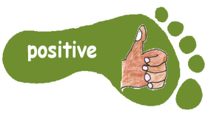 | Go for a walk around your local area. How many rocks can you see used different purposes? What makes each rock suitable for what it is used for? Take photos of what you see | Read about how the people in the Stone Age counted  https://nrich.maths.org/2472  Choose something to count and record in a tally when you are out and about. | Stone Age people build shelters to live in using materials they had gathered. Gather some natural materials and build a model shelter. Take a photograph of your shelter to send in.
Class 3 Home Learning Stone Age to Iron Age
Please do FIVE activities from the grid. Do at least one task from each subject area. Some tasks will take longer than others; an approximate guide is 30 minutes – 1 hour per activity. Please label written work with your NAME. You can colour the grid as you go to keep track of the tasks you have done. If it’s practical task, just a signature from your parent on the grid is great. The grids will be collected in and tasks should be completed by Tuesday 21st October. Parents Thank you for your support with homework. If you have any questions, do ask.

