Class 3 Homework Beside the Seaside Summer 2
 | Mathematical | Literacy | Science / Geography | Creative
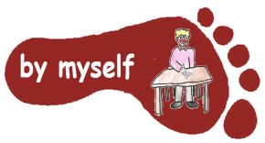 | Carry out a survey of the amount of plastic items thrown away in your home over a weekend.  Are there any items that can be recycled or reused? | Write a short story set at the seaside.  Perhaps you could write an adventure story about a rescue at sea. Or a fantasy story about a sand sculpture that comes alive. | Visit a local beach.  What living things can you find? Take photos or draw pictures of some of the things you find. Use an identification sheet to find out what some of these organisms are.  https://www.wildlifewatch.org.uk/animal-habitats/marine | Listen to pieces of classical music inspired by the sea https://www.bbc.co.uk/programmes/  articles/3Fm3H66YnxNZslLrSX3  mMvh/top-six-sea-pieces  Think about which was your favourite and why? What does each piece make you think about?
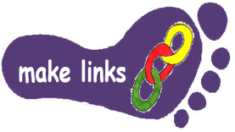 | During a trip to the beach, find out about the size of pebbles at different parts of the beach, eg are the pebbles larger at the top of the beach or near the sea? Measure and record a sample in 3 different places. What did you discover? | Listen to or read some poems that are about the sea.  There are several on this website:  https://childrens.poetryarchive.org  /collections/under-the-sea/  Which is your favourite why?  How does each one make you feel? | Look at Google maps or an OS map of the coast. How many different coastal features can you find? Eg can you find a spit, a cove, a headland, a stack, a mudflat, a harbour?  Or On a visit to the beach, draw a sketch map to show the physical and human features at this location. | Make a collage or sculpture using items collected from a beach, or during a visit to the beach. Take a photograph if it is a temporary piece of artwork.
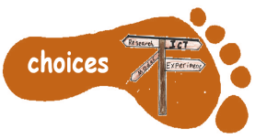 | Find out some interesting facts and figures about the sea by doing some research on the internet.  Present the information in a table, graph or chart | Choose an animal that is found living on a beach or in the sea. Carry out some research about this animal.  Make a Powerpoint or an information page about this animal. | Make a poster to tell people how to look after our coastline or oceans.  You can find out more about pollution at this website:  https://www.wwf.org.uk/sites/  default/files/2020-02/WWF_Plastics_Explainer.pdf | Plan and make one or more picnic items for you and your family that would be suitable for a day out at the beach.
Some tasks will take longer than others – a guide is spend 30 minutes – 1 hour on each activity. You need to complete FIVE tasks; one task from each subject area. Please NAME your work and hand in written work as you do it, rather than leaving it all to the end of the term! The homework tasks need to all be done by Tuesday 15th July . Colour the grid as you go to keep track of the tasks you have done. If it’s a practical task – a signature from your parent on the grid is needed. A labelled photograph would be good, if you can. We look forward to finding out what you have been learning at home.

