Class 3 Homework Charlie and the Chocolate Factory Name:
 | Maths | Literacy | Science / Technology | Creative
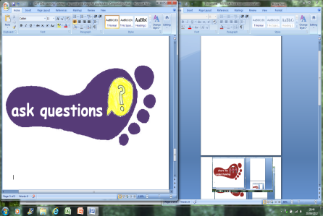 | Try one of these maths problems  The puzzling sweet shop  https://nrich.maths.org/14450  Sweets in a box  https://nrich.maths.org/84 | Write a description of a naughty child that might visit Willy Wonka’s Chocolate Factory.  Remember to include details-  Looks, speech (WHAT they say and the WAY they say it tells your reader about their character). Action (WHAT they do and the WAY they do it needs to match the nasty nature of your character). | Can you think of a question about chocolate you could test by carrying out a scientific experiment?  For example:  Does chocolate melt quicker if it is cut up into smaller pieces?  Carry out the test and write about what you found out. | Visit Roald Dahl Museum and Story Centre.  Great Missenden, England, HP16 0AL  (NB approx 1hr 40min journey from Upham).
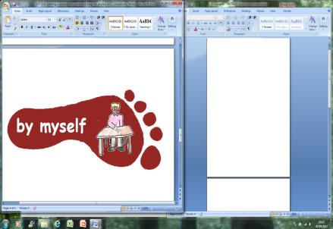 | Write some Charlie and the chocolate factory themed worded problems using add subtract times and divide.  Remember to do an answer sheet too. | Read a chapter or more (with help if you need it) from any other Roald Dahl book .  Write a review:  What vocabulary did you like?  How did Roald Dahl capture your interest?  Does the end of the chapter make you want to read on? Were there parts that you didn’t like? Why? | Find examples of different solids liquids and gases around your home and out and about. Can you find everyday examples of melting, solidifying, evaporation and condensation. Take photos of what you see and find out. | Make a magazine or TV advert for a new sweet or product made in Mr Wonka’s factory.  Remember to use persuasive vocabulary to help sell your product.
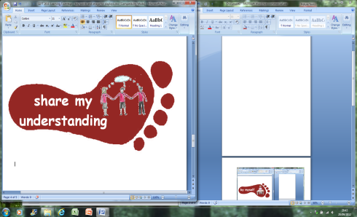 | Bake a chocolate cake or make some sweets  Measure out your own ingredients.  Set the timer so your cake doesn’t burn. | Make up your own poem about one of the characters in Charlie and the chocolate factory. Use rhyming words like the poems in the books. | Use Scratch, Stop Movie or any other animation software to  make a simple animation with one or more characters from Charlie and the Chocolate Factory.  (We will be using Scratch in school this half term, so your child should learn how to use some of the features of this program). | Make a model of one of the rooms in Mr Wonka’s factory.

Some tasks will take longer than others – a guide is spend 30 minutes – 1 hour on each activity. You need to complete FIVE tasks. Tasks to be completed by Tuesday 1st April. Colour the grid as you go to keep track of the tasks you have done. Please hand in the tasks as you go along rather than leaving them all to the end! If it’s a practical task – a signature from your parent on the grid is needed. Please ask if you have questions related to homework.

