Class 3 Homework Rotten Romans Name
 | History | Literacy | Maths | Art / DT
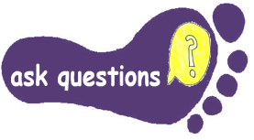 | If you are happy to venture further afield, a perfect place to visit is the Roman baths in Bath.  Closer to home you could visit Porchester Fort which was built by the Romans.  Ask questions you want to  find out on your visit. | Write a list of questions you would like to find out about Ancient Rome.  Go to the library and choose a non-fiction book about the Romans. Find the answers to your questions. | Choose one of the times tables.  Write it out using Roman numerals. | Ask questions about what Romans ate.  Prepare a Roman recipe or banquet at home.
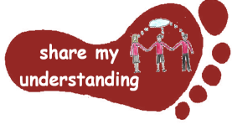 | Make a Powerpoint presentation about an aspect of Roman life that interests you eg  Roman Gods, Julius Caesar, pastimes, role of women | Make a leaflet or poster about something you found out when you visited the Roman baths or Porchester fort. Include pictures of the visit. | Write a set of worded questions with a Roman theme using add, subtract multiply and divide.  Remember to include the answers too. | Make a Roman Shield  Explain how Roman soldiers used shields in battle.
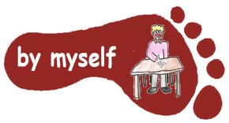 | Read more about life in Roman times at https://www.bbc.co.uk/bitesize/topics/zwmpfg8/articles/z2sm6sg  Do the quiz and activity on this page. | Read the Roman myth Jupiter and the Bee  Answer questions about this myth  (See resources on Class3 website) | Make a simple board game with a Roman theme. Use Roman numerals if you can. | Make a Roman mosaic – you could use small pieces of card or paper, or perhaps pieces of broken tile.
Please do FIVE activities from the grid. Do at least one task from each subject area and aim for one from each Footstep. Some tasks will take longer than others; aim to spend at least 30 minutes – 1 hour on each activity . Please could all work handed be NAMED. Colour the grid as you go to keep track of the tasks you have done. If it’s practical task, a signature from your parent on the grid is needed.
The grids will be collected in and all tasks need to be completed by Monday 6th February.

