Class 3 Homework Autumn 2 River Deep, Mountain High
 | Mathematical | Literacy | Geography / Science | Creative
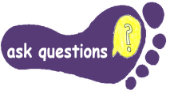 | Find data on ‘The highest mountains of the world’  OR the ‘Longest rivers of the World’  Create a bar chart to show the ‘TOP 5’ | Make a glossary  Find and record the meaning of key words , that describe parts of the river system-  Source Mouth Waterfall  Meander Valley Stream  Flood Estuary  Tributaries Erosion | Find out about tourism in a mountainous area for example the Alps. Make a page for a book to give tourists information about this location. Include information about the climate and things they can do in the area. | Create a Powerpoint presentation about a river or mountain of your choice.
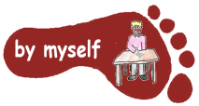 | Write some worded problems using the theme of rivers and mountains.  For example  Mount Everest is 8848m high. Ben Nevis is 1345m high How much taller is Mount Everest?  Remember to write the solutions too! | Write a poem about ‘Rivers’  Try to include at least 2 of the following- Powerful verbs, adverbs, alliteration, similes, metaphor, personification.  Use what you know to impress. Remember- It doesn’t have to rhyme. You could make it into a shape poem. | Watch an animation of the Water cycle at  https://www.bbc.co.uk/teach/class-clips-video/geography-ks1--ks2-the-water-cycle/zbcmxyc  Make a poster to show how the water cycle works.  Or make a model of the water cycle shown on this video clip.  https://www.youtube.com/watch?v=2rwFK5_Viqo | Create a piece of Art or design a model of a river or mountain  Be creative!
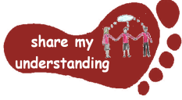 | Measure the temperature in your environment.  Either choose different places inside and outside your house to find the warmest and coolest position.  OR Record how the temperature changes through the day or through the week in the same place. | Diary/Letter-  Imagine that you are on an expedition to reach the top of a mountain.  Write an entry for 1 day of a diary or write a letter home.  Describe your experiences (e.g. weather, equipment)  Share your thoughts and feelings | Use a map to find rivers in the local area. Plan and go on a walk along a river. One suggestion is the River Itchen from The Hub in Bishopstoke. What can you find out about the river? For example: Look at the river as a habitat for plants and animals. Look at the direction of water flow. Can you find out where the source of the river is? Where is the end of the river’s journey? | Make a woollen pom-pom to go on the top of the hat you will be making in school.

Some tasks will take longer than others – a guide is spend 30 minutes – 1 hour on each activity.
You need to complete FIVE tasks; at least one task from each subject area. Please hand in written work as you do it, rather than leaving it all to the end of the term! The homework tasks need to all be done by Monday 12th December. Colour the grid as you go to keep track of the tasks you have done. If it’s a practical task, just a signature from your parent on the grid is fine. You can email completed tasks to class3@upham.hants.sch.uk
Enjoy choosing and carrying out the tasks, do ask if you have any questions. We look forward to finding out what you have been learning at home.

