Class 3 Homework Autumn 1 2024 Blood, Bones and Body Bits
 | Mathematical | Literacy | Science | Other curriculum area
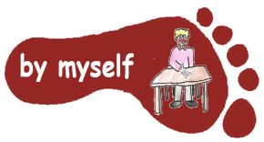 | Write some worded problems linked to the theme of the body.  For example,  If there are 10 children how many fingers do they have altogether?  How many more adult teeth do humans have compared to baby teeth?  Remember to do an answer sheet. | Write a clear set of instructions to explain how to clean your teeth.  Remember to use time conjunctions eg first, next, finally.  Include pictures in your instructions. | Visit Marwell zoo. Find out about animals with and without a skeleton. What is the scientific name for each group? Can you find out anything about some of the animal’s teeth? | Make a skeleton collage, possibly using different types of pasta shapes.  Or choose some music and make up a skeleton dance. You could record a video of your dance to show the class.
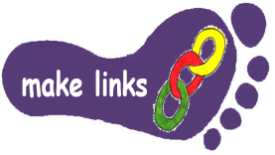 | What can you do in one minute?  Choose 5 different activities eg skipping, star jumps. Count how many you can do in 1 minute. Make a bar graph to show your results. | Visit the library and choose one or more non-fiction books about the human body. Write some questions you want to find out. Use the index and contents to help you locate the information to answer your questions. | Make a chart to show the different foods you eat in a day. Show which food groups – eg protein, carbohydrate each food belongs to.  Do you have a balanced diet? | Make a poster about Healthy Living. Include information about different aspects of being healthy eg diet, exercise, sleep
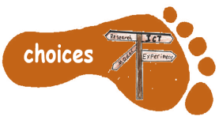 | Choose one of these maths challenges to try  https://nrich.maths.org/10070  https://nrich.maths.org/sandwiches | Choose one part of the body eg heart, muscles, ear  Find out about what it does and how it works.  Make an interesting fact page. | Carry out an experiment to find how which liquid does the least damage to teeth.  Use hard-boiled eggs (the shell represents tooth enamel) in different liquids | Design and make your own healthy savoury snack.  It could be soup, a sandwich or a salad. Or maybe you have a better idea!
Some tasks will take longer than others – a guide is spend 30 minutes – 1 hour on each activity.
You need to complete FIVE tasks; one task from each subject area. Please hand in written work as you do it, rather than at the end of the term! You are welcome to e-mail tasks to class3@upham.hants.sch.uk if this is easier for you. Colour the grid as you go to keep track of the tasks you have done. If it’s a practical task – a signature from your parent on the grid is needed.
The homework tasks need to all be completed and handed in by WEDNESDAY 23rd OCTOBER. Enjoy choosing and carrying out the tasks. We look forward to finding out what you have been learning at home. If you have any questions please come and ask.

