Badger Class Homework – Meet the Greeks Name
 | Maths | English | History | Art/DT
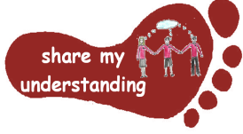  Share my understanding | Use your different mathematical skills to help you solve the attached Greek word problems.  M1 | Find out about what Greece is like now. Create a holiday brochure encouraging people to visit this country.  E1 | Find out about how the Olympic Games began. Write a short explanatory text to share your findings.  H1 | Create your own sculpture or piece of pottery in an Ancient Greek style.  A1
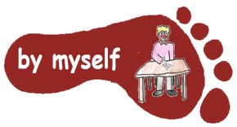  By myself | Have a go at the attached triangular and square numbers activity.  M2 | Read through the attached text about Greece and answer the comprehension questions.  E2 | Find out about the Ancient Greek Gods. Create a PowerPoint or fact page to share this information.  H2 | Create your own Greek temple model.  A2
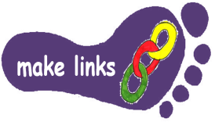  Make links | Find out about Pythagoras’ theorem which is used to help work out the lengths of sides of triangles – see attached sheet. (Please be aware this one is particularly tricky!) M3 | Write your own Greek myth or legend. Think carefully about setting, characters and plot, making links to your knowledge of this writing genre.  E4 | Create a timeline showing the key events in the time of the Ancient Greeks.  H3 | Use the Ancient Greek alphabet to create your own name card or message and decorate.  A3
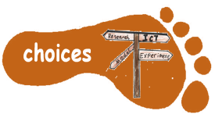  Make choices | Use BBC Bitesize to revise an area of Maths you feel you need more practise on ready for SATs. Create a revision poster to help you revise.  M4 | Read some Greek myths and legends. Choose one to retell in your own words.  E4 | Find out about an aspect of life which interests you during the time of Ancient Greece. Choose how you present the information you gather.  H4 | Build your own Trojan horse using materials of your choice.  A4

I would like Year 5 children to complete FOUR activities and Year 6 children to complete THREE activities from the grid. Do at least one task from each subject area and aim for one from each Footstep. Please label your work with YOUR NAME and the code on the grid. Colour the grid as you go to keep track of the tasks you have done. If it’s a practical task, a signature from your parent on the grid is needed. The maths tasks are all attached to this sheet. The grids will be collected in and all tasks need to be completed by MONDAY 18th MAY.
Enjoy choosing and carrying out the tasks. I look forward to finding out what you have been learning at home. Miss Leech

