Class 4 Homework - The Sound of Music! Name __________
 | Maths | Science | Music
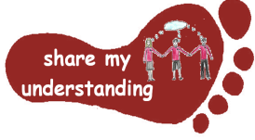  Share my understanding | Look at the pictures on the sheet. Which fractions can you see? Explain your ideas and reasoning clearly.  M1 | Create a poster or PowerPoint to share your understanding of how sounds are made and how we hear them.  S1 | Pick a country of your choice. Find out about the instruments which are played there and explore how sound is produced using these instruments. Then decide how to present your findings (fact page, PowerPoint…).  MU1
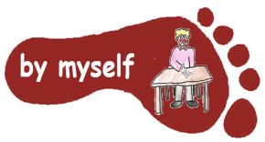  By myself | Pick one of the fraction worksheets to complete. Remember to read the ‘Look and Learn’ section at the top so you know what to do.  M2 | Carry out the attached sound survey either at home or outside to explore what you can hear.  S2 | Find a song or piece of music which has been composed about Easter. Listen to the song a few times, then fill in the ‘Reacting to Music’ sheet.  MU2
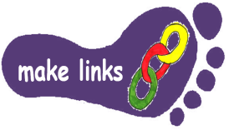  Make links | Complete the Maths Mystery challenge. The Mystery of Pinebridge Village. This will involve making links between lots of different mathematical skills.  M3 | Play the ‘Good Vibrations’ game attached with your family or friends. You will need to make links between your scientific and musical knowledge and understanding.  S3 | Design and make your own musical instrument.  MU3
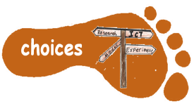  Make choices | Choose of an area of maths you are finding tricky – it could be something like long division or fractions. Create a revision poster to help you remember how to do it.  M4 | Use your knowledge and understanding of sound to design and make your own set of earmuffs to provide insulation against sound.  S4 | Create your own music video. It could be a documentary about an instrument or composer you are interested in, a film of you playing/singing, a piece of music you have composed...  MU4

Year 5 pupils need to complete FIVE activities from the grid, Year 6 pupils need to complete THREE activities (because they will be doing extra work for SATs club). Do at least one task from each subject area and aim for one from each Footstep. Please label your work with YOUR NAME and the code on the grid. Colour the grid as you go to keep track of the tasks you have done. If it’s a practical task, a signature from your parent on the grid is needed. The grids will be collected in and all tasks need to be completed by Friday 27th MARCH Enjoy choosing and carrying out the tasks. I look forward to finding out what you have been learning at home. Miss Leech

