Badger Homework - Extreme Sports (Forces) Name ____________
 | Maths | Literacy | Science
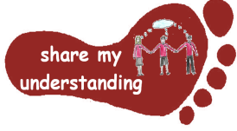  Share my understanding | Practise using the long multiplication method at home. Then write a set of instructions for how to use this method which you can use to help you revise for future tests.  M1 | Create a short documentary film either explaining how an extreme sport of your choice works or sharing your understanding about what forces are and how they work.  L1 | Find out about how Galileo Galilei and Isaac Newton helped to develop the theory of gravitation. Summarise what you found out.  S1
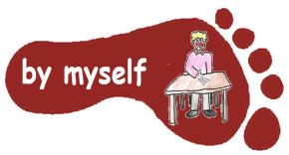  By myself | Work through the ‘Olympics Ordering’ task, which will help you revise decimal numbers and ordering.  M2 | Imagine you have tried an extreme sport for the first time. Write a diary entry to share what the experience was like. Try to include some figurative language (e.g. similes and metaphors).  L2 | Find out about how the size, shape and weight of an object affects how it floats. Create your own boat/raft that will float using this knowledge.  S2
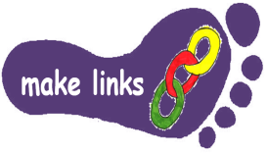  Make links | Have a go at the ‘Sabotage at the Ski Resort’ activity. This will involve making links with different areas of maths. (Please note – this is probably the hardest activity on offer!)  M3 | Research an extreme sport of your choice. Create a non-chronological report to explain what this sport is and how it works. If you can, describe which forces are involved in this sport.  L3 | Find out how a kite flies and the forces which act on it. Then make your own kite to fly on a windy day.  S3
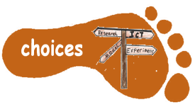  Make choices | Complete the Sports Day Code breaker which involve solving maths calculations to answer sport-themed jokes. Which is your favourite? Use the code to create your own joke.  M4 | Create an advert for an extreme sport of your choice. Make sure you include persuasive language to encourage your reader to try it.  L4 | Design your own investigation to test the amount of friction produced by different materials. Record your results and write a conclusion to share what you found out.  S4

Year 5 pupils need to complete FIVE activities from the grid, Year 6 pupils need to complete THREE activities (because they will be doing extra work for SATs club). Do at least one task from each subject area and aim for one from each Footstep. Please label your work with YOUR NAME and the code on the grid. Colour the grid as you go to keep track of the tasks you have done. If it’s a practical task, a signature from your parent on the grid is needed. The maths tasks are all attached to this sheet. The grids will be collected in and all tasks need to be completed by MONDAY 9th February. Enjoy choosing and carrying out the tasks. I look forward to finding out what you have been learning at home. Miss Leech

