Badger’s Homework – The Vicious Vikings Name _____________
 | Maths | Literacy | History | D.T / Art
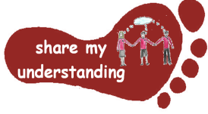  Share my understanding | Create a poster explaining how to use the column method for addition and subtraction.  M1 | Write a diary entry showing what a typical day would be like for a Viking.  L1 | Find out about the Viking Runes. Explain how they worked and try writing a short message using them.  H1 | Build a model of a Viking house.  DT1
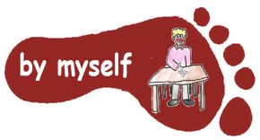  By myself | Work through the Viking Maths challenges attached.  M2 | Write your own Viking myth or legend.  L2 | Find out about Viking boats. Create a labelled diagram to show what each part was and how it helped the Vikings to travel.  H2 | Create a Viking shield or helmet.  DT2
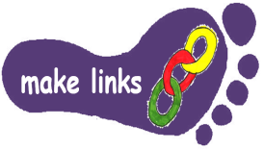  Make links | Create a set of Viking worded maths problem. Try to include some multi-step problems if you can. Remember to include an answer sheet!  M3 | Write your own poem around the theme of Vikings. You can use ideas from our work on Remembrance Poetry to help you.  L3 | Find out about Viking clothing. Compare and contrast what the Vikings wore to what we wear now.  H3 | Use a medium of your choice to create a Viking picture.  DT3
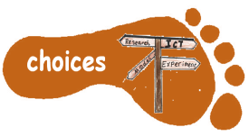  Make choices | Visit the website:  www.topmarks.co.uk/maths-games/7-11-years/times-tables  Choose a game to play to help you practise your times tables.  M4 | Find out about an aspect of Viking life of your choice. You can choose how you present this information, for example, fact page, PowerPoint, short information book.  L4 | Create a Viking quiz/puzzle of your choice.  H4 | Find out about what Vikings ate. Have a go at cooking a Viking-inspired item or meal.  DT4

I would like you to do FIVE activities from the grid. Do at least one task from each subject area and aim for one from each Footstep. Please label your work with YOUR NAME and the code on the grid. Colour the grid as you go to keep track of the tasks you have done. If it’s a practical task, a signature from your parent on the grid is needed. The maths tasks are all attached to this sheet. The grids will be collected in and all tasks need to be completed by Monday 8th December.
Enjoy choosing and carrying out the tasks. I look forward to finding out what you have been learning at home. Miss Leech

