Badger Class Homework - Upham Bake Off Name _______________
 | Maths | English | Science | DT
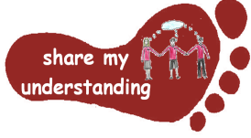  Share my understanding | Work through the place value riddles – can you work out what the number is?  M1 | Create your own short cooking documentary film. Film yourself cooking and explain clearly each step involved for your audience.  E1 | Choose four different materials and write down what their properties are (e.g. hardness, transparency, conductivity). Find out what they can be used for. S1 | Create a poster to show what the different food groups are. Give examples of foods which belong to each of the food groups.  DT1
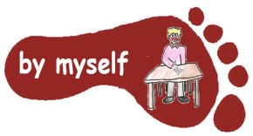  By myself | Choose some different food items from your kitchen, estimate their weight, then use scales to check. Record your results in a table.  M2 | Imagine you are a baker or a chef working in a busy kitchen. Write a diary entry to describe your normal day.  E2 | Find out about how chemists create new materials. You might want to look at the work of Spencer Silver or Ruth Benerito to give you some ideas. S2 | Keep a food diary of what you eat over 1 week. Think about which food group each item belongs to.  DT2
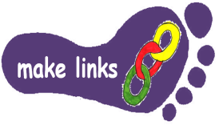  Make links | Create your own set of worded problems linked to our topic. Remember to include an answer sheet!  M3 | Make up your own recipe for a biscuit or cake. Use ideas from real recipes to help you.  E3 | If you have a magnet at home, explore which materials are attracted to it. Record your findings in a table and write about what you find out.  S3 | Find out about foods which can be grown in our country at this time of year. Record your findings, and if you can try and grow something of your own.  DT3
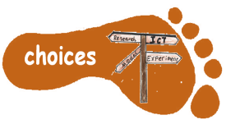  Make choices | Choose one of the attached number and place value maths worksheets to work through.  M4 | Watch an episode of The Great British Bake Off or another food programme of your choice and write a review.  E4 | Plan and carry out your own investigation at home to find out about materials which can dissolve into water and those which cannot. Record your findings.  S4 | Find a recipe which interests you. Follow this carefully and take a photo of your finished product or bring in some for us to try!  DT4
This is the first homework grid this year. I would like you to do FIVE activities from the grid. Do at least one task from each subject area and aim for one from each Footstep. Please label your work with YOUR NAME and the code on the grid. Colour the grid as you go to keep track of the tasks you have done. If it’s a practical task, a signature from your parent on the grid is needed. The maths tasks are all attached to this sheet. The grids will be collected in and all tasks need to be completed by Monday 20th October. Enjoy choosing and carrying out the tasks. I look forward to finding out what you have been learning at home. Miss Leech

